Tsogo Sun has advised that the Southern Sun OR Tambo is no longer in operation.

Great Plains is excited to announce the opening of their new Tembo Plains Camp, located in Zimbabwe’s Sapi Reserve, on 1 August 2021, as well as the launch of the Great Plains Expeditions experience in Botswana. Please contact your Journey Specialist for more information.

Minor Hotels has advised that due to new Zambia Wildlife Authority rules, they will no longer offer unlimited access to the Falls from any of their properties in Zambia.

The Palm River Hotel Zimbabwe, located in Victoria Falls, is scheduled to open 1 July 2021.

Onguma Collection has introduced the Dream Cruiser, offering guests the opportunity to spend a night in a luxury rooftop tent in the wilderness at Onguma Reserve.

Sandwich Harbour 4 x 4 is excited to introduce their Shipwreck Sandwich Harbour excursion, as well as a 3-day Shipwrecks and Diamond Camps excursion. Please contact your Journey Specialist for more information.
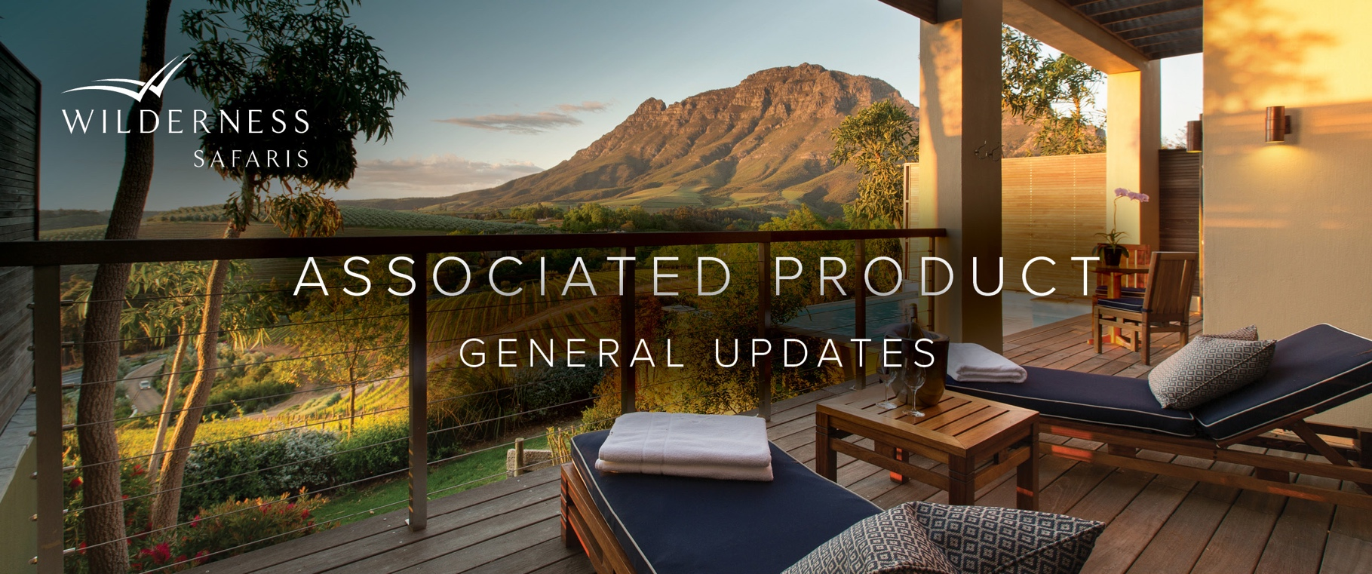

e&oe 8 June 2021 © Wilderness Safaris

