Red Carnation – Stay for a minimum of 4 nights at Xigera Safari Lodge, and get 2 free nights at either The Twelve Apostles Hotel or The Oyster Box. Offer valid until 19 December 2021 and 06 January 2022 to 19 December 2022.
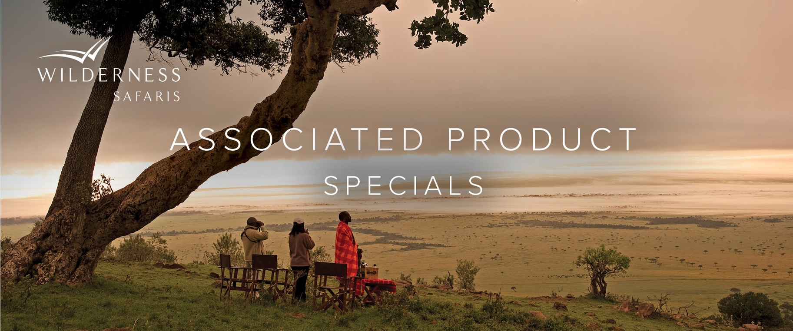

e&oe 4 June 2021 © Wilderness Safaris

Le Cle Des Montagnes – Stay for 2 weeks at Le Cle Des Montagnes and receive a 35% discount. Offer valid until 20 December 2021.

Kwandwe Private Game Reserve – Enjoy a 40 % discount when you stay for 2 weeks, or save 50% when you stay for 3 weeks. Offer valid until 30 September 2021.

