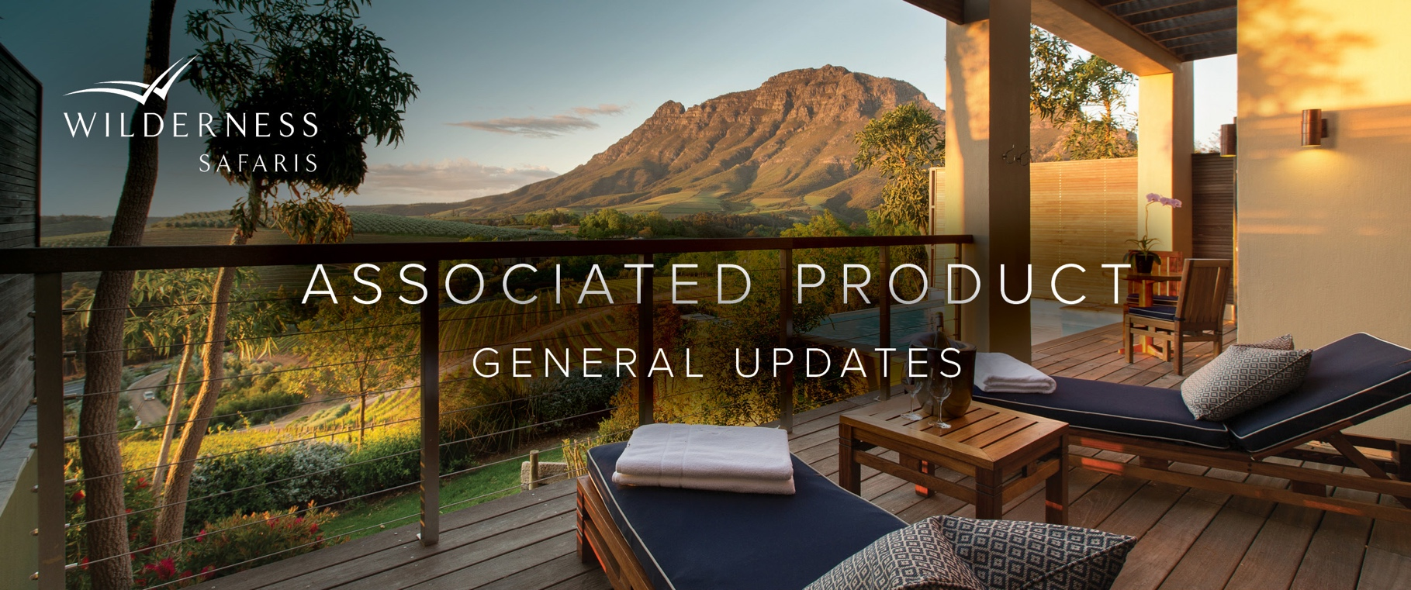
The Blue Train has announced that all services have been suspended, with immediate effect.

Tanda Tula has announced the temporary closure of its Safari Camp, which is undergoing a full refurbishment.

The Royal Portfolio is excited to announce the introduction of their new property, Waterside at Royal Malewane, which is scheduled to open on 01 July 2022.

Simbavati Lodge Collection is delighted to announce that Simbavati Waterside, located in the Klaserie Private Nature Reserve, has joined their portfolio.

Kariega Game Reserve has incorporated an additional 1 500 hectares into its reserve in the pristine Bushman’s River Valley, expanding the reserve to 11 500 hectares.

The Cape Grace is excited to announce the re-opening of the Bascule Bar, with new operating hours from Wednesday to Saturday, 12pm till late.

The MORE Family has advised that the Cape Cadogan will be closed from 02 April 2022 to 19 December 2022 for an extensive refurbishment.

Sanctuary Retreats have advised that the owners of Makanyane Safari Lodge have made the decision to permanently close the property.

Machaba Safaris Update
- Set in Botswana’s Okavango Delta, the new Kiri Camp is scheduled to open in June 2022
- Verney’s Camp, in Zimbabwe’s Hwange National Park, is open and welcoming guests
- Overlooking the mighty Zambezi River, Mana River Camp is scheduled to open in May 2022
- Deka Camp, which is located in Zimbabwe’s Hwange National Park, will not be open throughout 2022

Victoria Falls Hotel has announced the temporary closure of Stanley’s Terrace Restaurant, until the end of April 2022, for renovations.

Angama is excited to announce the opening of its new Angama Amboseli Camp. The official opening date will be communicated in due course.

Bush & Beyond is excited to announce the introduction of their new property, Reteti House, which is located in the Namunyak Wildlife Conservancy.

Chem Chem Safaris has introduced a new cultural experience with the Barabaig Community in Tanzania.

Lemala Camps has announced the temporary closure of its Lemala Ngorongoro Camp from 18 February to 12 May 2023, to under a full rebuild.

Onguma Collection is delighted to announce the opening of its new Camp Kala, located in Onguma Nature Reserve, in November 2022.

e&oe 4 April 2022 © Wilderness Safaris

