BidAir Services is happy to announce that they now fall under the NAS Colossal Aviation Services portfolio.

Federal Air Updates
- Effective 01 January to 01 July 2022, there will be only one scheduled daily departure between OR Tambo and the Lowveld lodges as well as Madikwe. The two daily departures will recommence from 01 July 2022 for both routes.
- Due to the above reduction in daily departures, the Lowveld to OR Tambo flight will not arrive in time to connect to the 13h00 departure for those guests flying to Tswalu. Once the two daily departures recommence on 01 July 2022, this will be possible once again

Rovos Rail has advised that their Cape Town to Pretoria route has changed from two nights to three nights.

Sanbona has announced the temporary closures of its Tilney Lodge until the end of September 2022, Gondwana Lodge until the end of June 2022 and Dwyka Lodge until the end of July 2022, to undergo renovations.

The Table Bay Hotel has advised that the hotel’s exterior and restaurant terrace is being repainted, which takes place between the hours of 08h00 to 17h00 (Mon-Fri) and is scheduled for completion in mid-April 2022.

Grootbos is excited to announce that the refurbished Garden Lodge is scheduled to open in April 2022.

Cheetah Plains has announced the appointment of its new Head of Sales and Marketing, Mr Peter Dros, formerly of Fancourt.

Camp Hwange & Hwange Bush Camp have advised that they will no longer offer road transfers through Mbala Gate.

African Bush Camps is excited to announce the opening of its new Lolebezi camp, located in Zambezi National Park, in June 2022.

The Gondwana Groups is excited to announce that AM Weinberg Boutique Hotel in Windhoek has been added to their portfolio, effective 1 February 2022.

The Strand Hotel Swakopmund is undertaking its First Phase of building refurbishment works which is scheduled for completion on 30 April 2022.

Namib Sky Adventures Sossusvlei has advised that they will no longer offer transfers to and from its ballooning activities.

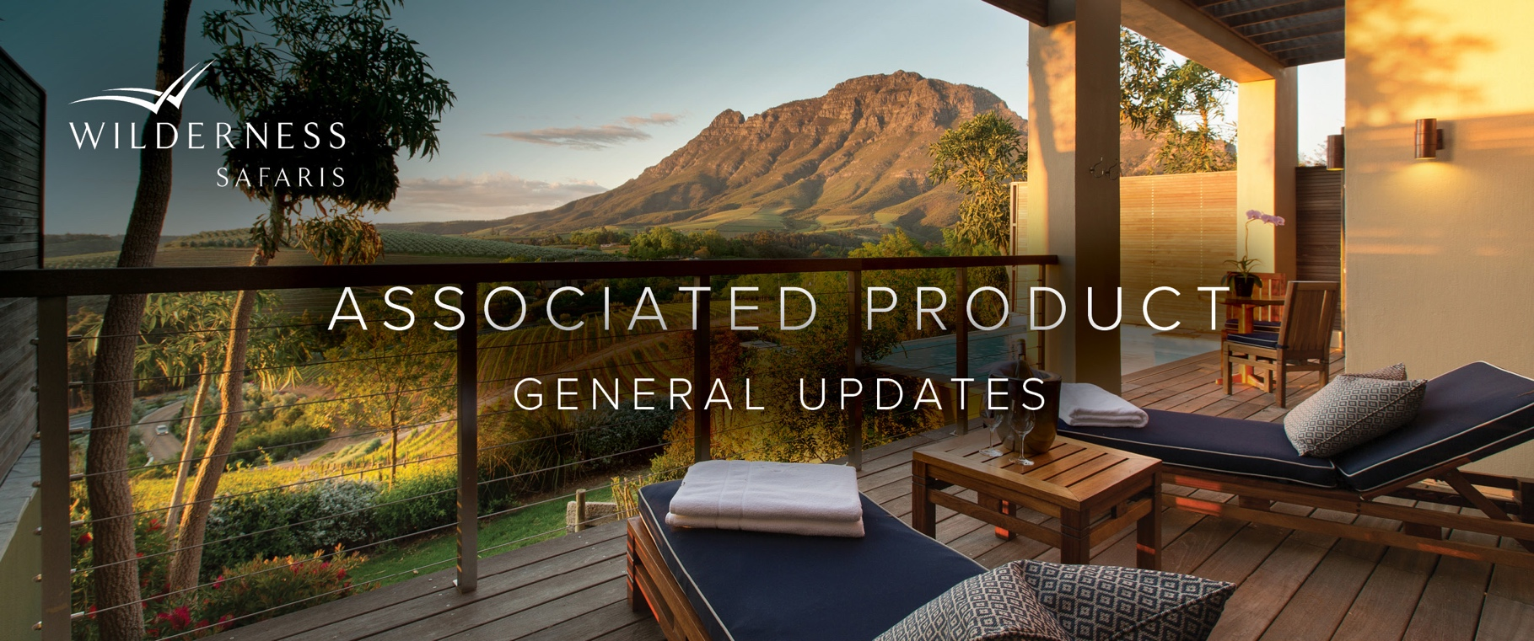
Airkenya Express is excited to announce the launch of its new flight schedule to Tsavo National Park, and has already commenced operation from Finch Hatton Airstrip.

Angama Airstrip is undergoing a refurbishment and will be closed until further notice.

Cottar’s Safaris has announced that Cottar’s Conservancy Camp has closed until further notice.
Asilia Africa Updates

e&oe 8 February 2022 © Wilderness Safaris

- The Highlands is excited to announce the opening of its new Asilia Spa and Sauna, in June 2022.
- Usangu Expedition Camp, located in the greater Ruaha National Park, is scheduled to open on 1 June 2022.
- Daily flights from the Serengeti to Rubondo Island National Park are now being operated by Auric Air.

