Kambaku Lodges
- Stay 4, Pay 3 at either Kamabu River Sands & Kambaku Safari Lodge. Offer valid from 01 June to 30 June 2022, and again from 01 November to 30 November 2022.
- Stay 6, Pay 5 at either Kamabu River Sands & Kambaku Safari Lodge. Offer valid until 30 November 2022.
- Stay for a minimum of 3 nights at either Kambaku Safari Lodge or Kambaku @ Sea and a second child stays free. Offer valid until 30 November 2022.
- Stay a minimum of 7 nights at Kambaku @ Sea and receive a 20% discount. Offer valid until 30 November 2022.

Tswalu
- Stay 3, Pay 2; Stay 4, Pay 2; Stay 5, Pay 3 or Stay 7, Pay 5 special. Offers valid until 30 April 2022.

Delaire Graff
- Enjoy an additional 15% discount when you book before 31 April 2022.

Mount Nelson
- Stay 3, Pay 2 special. Offer valid from 01 May to 31 August 2022.
- Stay 4, pay 3 special. Offer valid from 01 April to 30 April 2022, and again from 01 September to 31 October 2022, in any room type and 01 February to 31 March 2022, and again from 01 November to 24 December 2022 in the Junior Suite categories and above.

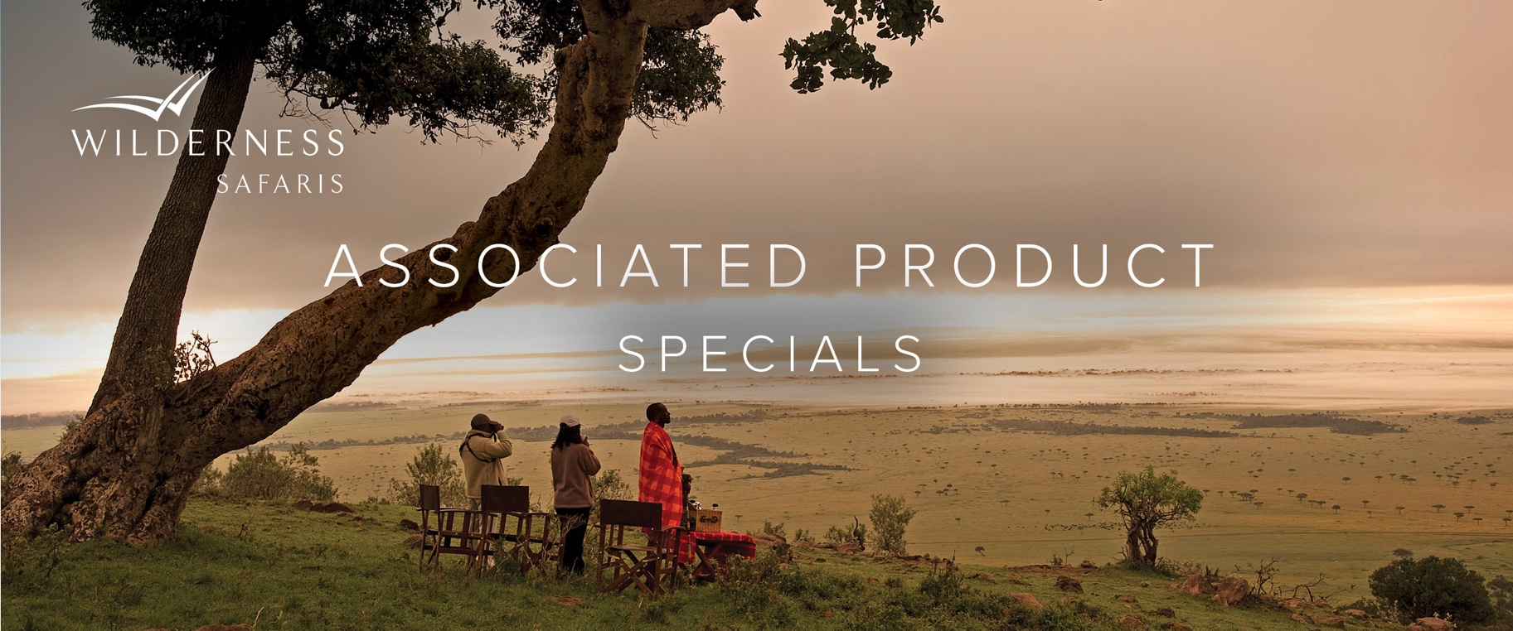
Time & Tide

e&oe 4 February 2022 © Wilderness Safaris

- Stay a minimum of 4 nights at both King Lewanika and Chinzombo, and receive a complimentary night at the Return to the Wild sleep-out and at Latitude 15 respectively (includes return airport transfers). Offer valid until 31 May 2022.

Please speak to your Travel Designer for more information.

