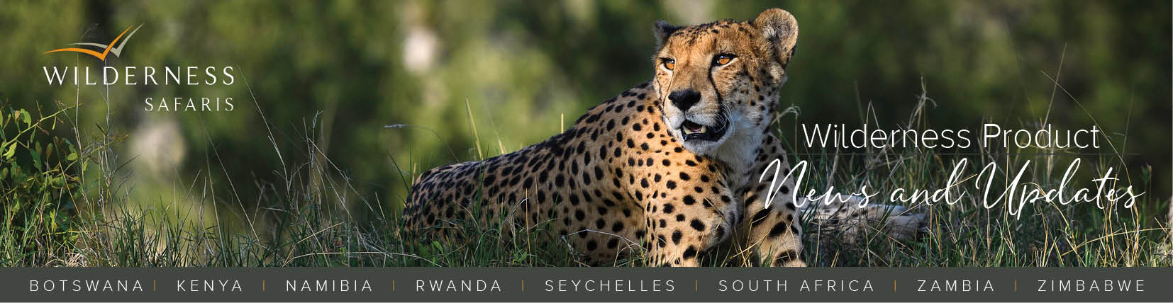
25 June 2018

NEWSFLASH

Revamped Documentation
We are in the process of rolling out our new-look documentation! Contact your Journey Specialist for further details including costs, but changes include:
- A new Wilderness Safaris branded leather wallet, leather baggage tags and metal pen. The wallet was designed to hold an iPad/tablet so that guests may continue using it after their safari.
- Rejuvenated content for the Journey Itinerary - visual with plenty of images, new fonts and printed on quality paper.
- New colours and textured paper for the itinerary and voucher covers.
- Updated country species checklists.

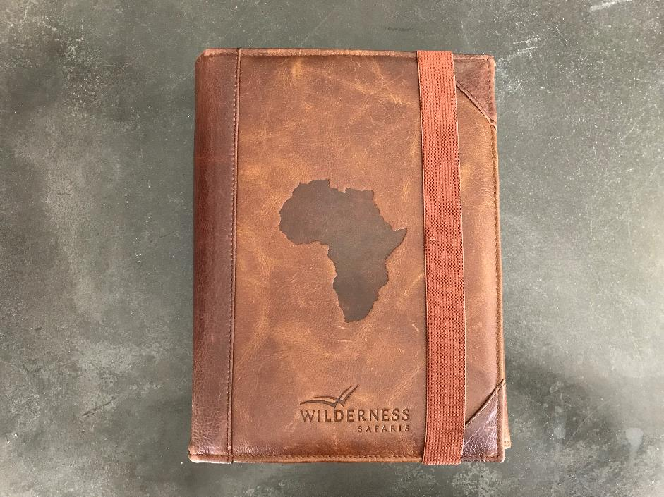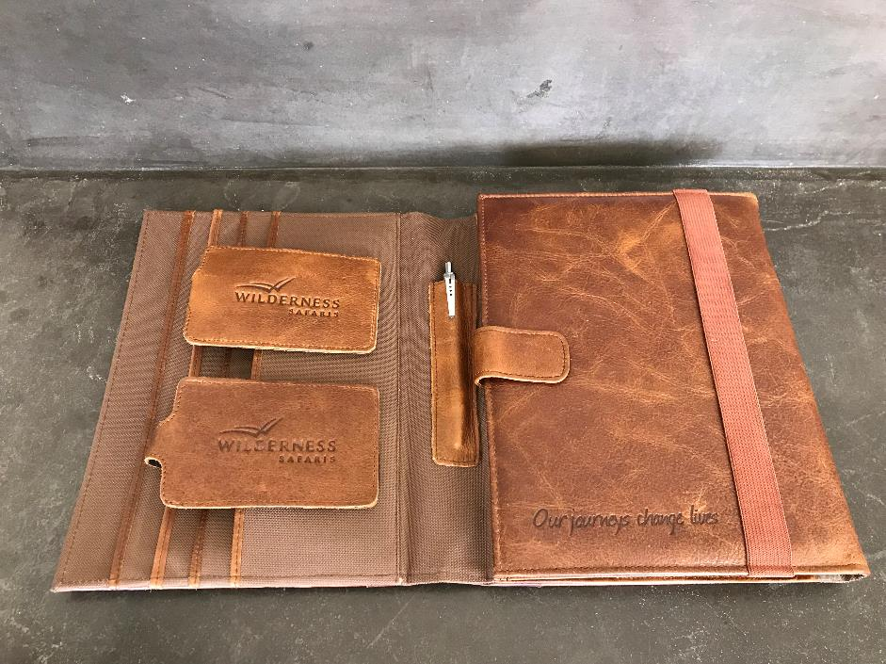

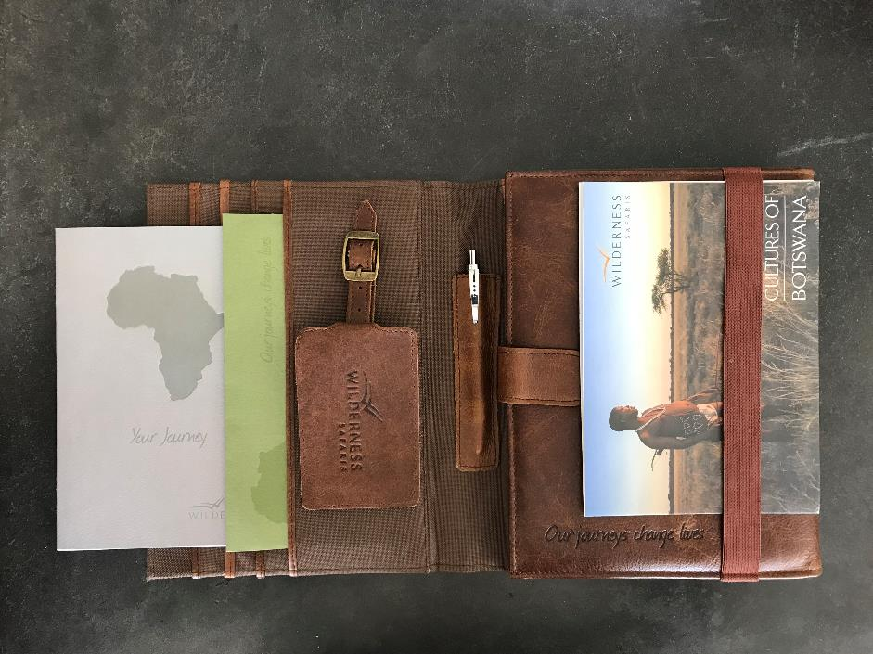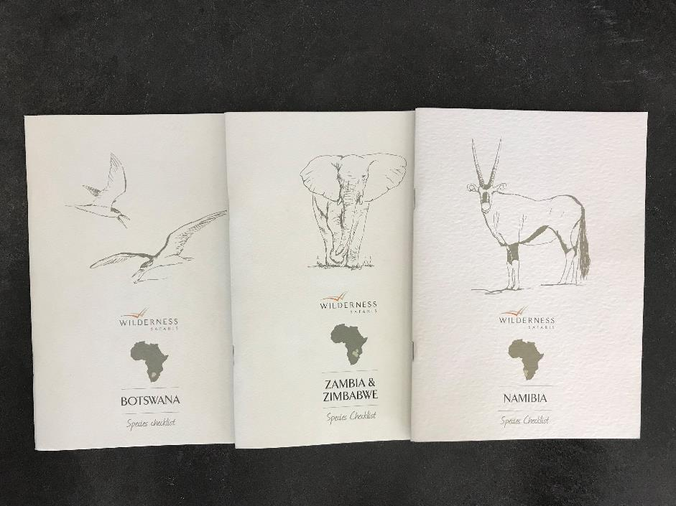

New Wilderness Safaris Travel Bags
- Along with our new documentation, we have also designed new travel bags. Made of canvas, with a leather trim and wheels at one end, they conform to the parameters required for travelling in light aircraft.
- At additional cost, it is possible to purchase co-branded bags. A debossed leather patch with your logo (no colours) would be added on the opposite side of the bag to the Wilderness patch.
- We are in the process of arranging distribution and finalising costs including courier fees. Please contact your Journey Specialist for further information.

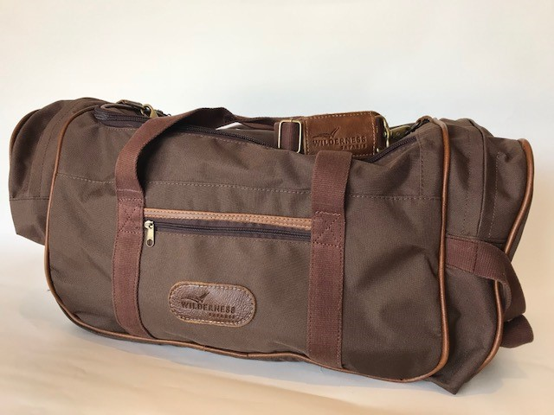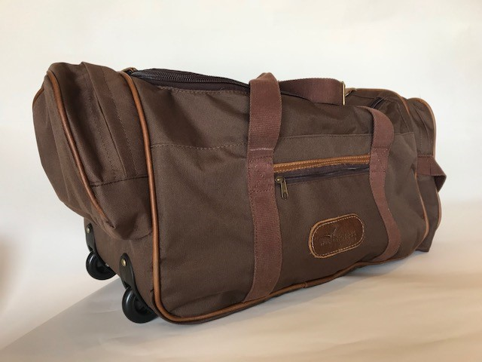

IMPORTANT

LIVE | Magashi in Akagera National Park, Rwanda
- Opening on 21 December 2018, we are now taking bookings for Magashi.
- Rates have been added to the published Rwanda Nett Rates Sheet available on the Wilderness Window.
- A Camp Information Sheet providing details on camp facilities, activities, access, etc. is also available on the Window, and relevant details have been added to our Pre-tour documents.

Exciting Developments at Wilderness Air Namibia
- Sole use charters: we are once more in a position to offer this service due to additional aircraft joining the fleet!
- The introduction of lodge hops: from 1 July 2018, you will be able to book lodge hops between selected destinations, outside of the standard circuit, which include Swakopmund, Wolwedans, Ongava, Mokuti and Okonjima.

Rate Changes
In the last year or so, a number of our camps have undergone extensive renovations and refurbishments. Accordingly, some rates have increased – specifically for peak season 2019. These increases apply to all new bookings placed from 28 May 2018 while all existing bookings placed prior to that date, will be honoured at the previous rates. Note too that the pilot/guide rate at Mombo increased for the full 2019 season. Our updated published nett rates sheets are available online, and I would encourage you to refer to these to ensure you have the most current rates to hand.

TRAVEL REGULATIONS

Change in Visa Requirements for Chinese tourists visiting Zimbabwe
As of 1 July 2018, the Zimbabwe government will relax visa restrictions for Chinese tourists. China will move from a Category C to a Category B – i.e. instead of visas required ‘prior to travel’, they may be obtained on arrival. Category A refers to countries whose nationals are exempt from visa requirements; Category B to those required to obtain visas at the port of entry (on arrival); and Category C to those required to apply for visas prior to travel. In addition, this relaxation is not only limited to China but extends to 36 other countries, including Equatorial Guinea, Iran, Algeria, Turkey and Cuba.

WILDERNESS SAFARIS PRIVATE JOURNEYS – CAPE

New Vehicles in the Fleet
Private Journeys have upgraded their vehicles with a key change being the replacement of two Land Rover Discoveries with two Audi Q5s, plus access to a Mercedes Viano. Private Journeys can also book any other car that guests request on a price on application basis – vintage, sports, luxury, etc.

WILDERNESS TOURING & TRANSFERS – ZAMBEZI

Livingstone Island Activities Resumed on 18 June
Note that there have been a few amendments, including changes to the menu and a revised child policy - where children must be 12 years and older to take part, and will pay the standard adult rate.

BOTSWANA

CHANGE | Visits to Deception Valley from Kalahari Plains
Going forward and for operational reasons, a visit to Deception Valley will only be included on a stay of three nights or more. To guarantee the excursion to Deception on a stay of only two nights, a private vehicle will need to be booked and charged for.

Water Activity Update
- Still no boating activities at Abu and Seba - they are only doing mokoro excursions.
- Boating/mokoro activities are on offer as normal at the other Wilderness camps.
- Jao Concession:
- Jao camp - full mokoro activity 15 minutes’ drive from camp. Full boating from the Jao jetty, with excursions to Hunda a 45-minute boat ride one-way.
- Kwetsani Camp – full mokoro activity 5 minutes’ drive from camp. Full boating from the jetty on Kwetsani Island (3-minute drive from camp), with excursions to Hunda a 15-minute boat ride one way.
- Pelo Camp - full boating and mokoro activities. Transfers to the airstrip are by boat and vehicle (35-minute boat ride from the camp jetty to Nkwe jetty, and a 15-minute drive to the airstrip).
- Jacana Camp - full mokoro and boating activities direct from the main area. Transfers to the airstrip are by boat and vehicle (20-minute boat ride from the camp jetty to Nkwe jetty, and a 15-minute drive to the airstrip).
- Tubu Tree - full boating (20-minute drive from camp) and mokoro (15-minute drive from camp) activities.
NAMIBIA

NEW | Service Fee for Use of Wilderness Safaris Namibia Airstrips
Wilderness Safaris Namibia have implemented a mandatory service fee applicable to all users of our airstrips. Effective 1 September 2018, an amount of NAD 400.00 per landing will be charged to all air charter companies for drop offs and collections at Wilderness Safaris Namibia airstrips. Wilderness Air Namibia have elected to absorb these costs so there is no change to their rates; however, other parties may adjust their rates accordingly. This fee serves to recoup the costs for services offered at these airstrips, including extra personnel required to facilitate each landing.

No Boating at Serra Cafema
Operations have advised that levels on the Kunene River have dropped drastically so for safety reasons, no boating is on offer for the foreseeable future.

HEADS UP |Proposed Ban on Plastic Bags in Namibia National Parks
Namibia plan to ban all single-use plastic bags in the country’s national parks. The Ministry of Environment and Tourism (MET) is currently working on measures and systems, which include the provision of waste or plastics disposal bins and proper signage at each park entry to inform the park visitors, residents and tourists accordingly. Once implemented, we will advise accordingly.

ZIMBABWE

Meet & Greet Service in Harare
This is a compulsory inclusion for all guests travelling to or from Harare Airport with Wilderness Air Zimbabwe, to ensure all runs smoothly. We do not have an office in Harare so this service is outsourced – hence the cost.

AIRLINES & AIRPORTS

Botswana Airports offer Free Wi-Fi
Botswana Investment and Trade Centre (BITC) has introduced free Wi-Fi for one hour at the boarding areas of four major airports - Sir Seretse Khama International airport in Gaborone, Kasane and Maun airports, as well as Francistown airport.

Air Seychelles Introduces New Baggage Policy
With effect from 1 July 2018, and applicable to the Seychelles, Mumbai, Abu Dhabi, and Mauritius routes - travellers in business class will now be entitled to 40kg of checked baggage and economy guests to 30kg. Hand luggage limits are set at 12kg for business class and 7kg for economy.

Fastjet Increase Frequency between Harare and Vic Falls
From 2 July 2018, the airline will service this route twice daily, six days a week, except on Saturdays, when there is only one flight between the destinations.

New Airline in the Works for Zimbabwe
Expected to take-off in September this year, Zimbabwe’s new airline, Sol Air plans to start with domestic flights and then gradually move into regional flights.

Airlink Increases Capacity on Hoedspruit Route
On 1 August 2018, Airlink will add a second flight between Johannesburg and Hoedspruit.

RwandAir Expands Network to North America and China
RwandAir has been granted a licence to start direct flight services to the United States (New York) and China (Guangzhou). While details are still being finalised, the arrival airport in New York will be either JFK or Newark, and the flights are likely to start towards the end of the year.

Proflight Launches Harare Route
On 9 July 2018, Proflight will fly four times a week between Lusaka and Harare - on Mondays, Tuesdays, Thursdays and Saturdays.

Four South African Airports Scheduled to undergo a Name Change
Cape Town International Airport, Kimberly Airport, East London Airport and Port Elizabeth International Airport will be undergoing a name change as part of the Transformation of Heritage Landscape Government programme.

SAA Releases Year-long Schedule to Sustain South African Express (SAX) network
Following the recent grounding of SAX for non-compliance, SAA has released an extended schedule in order to sustain the South African Express network, by providing replacement capacity. The schedule will run from 29 May 2018, to 28 May 2019.

*************************
Cheers
Tina
Wilderness Product Manager

www.wilderness-safaris.com
© Wilderness-Safaris 2018

