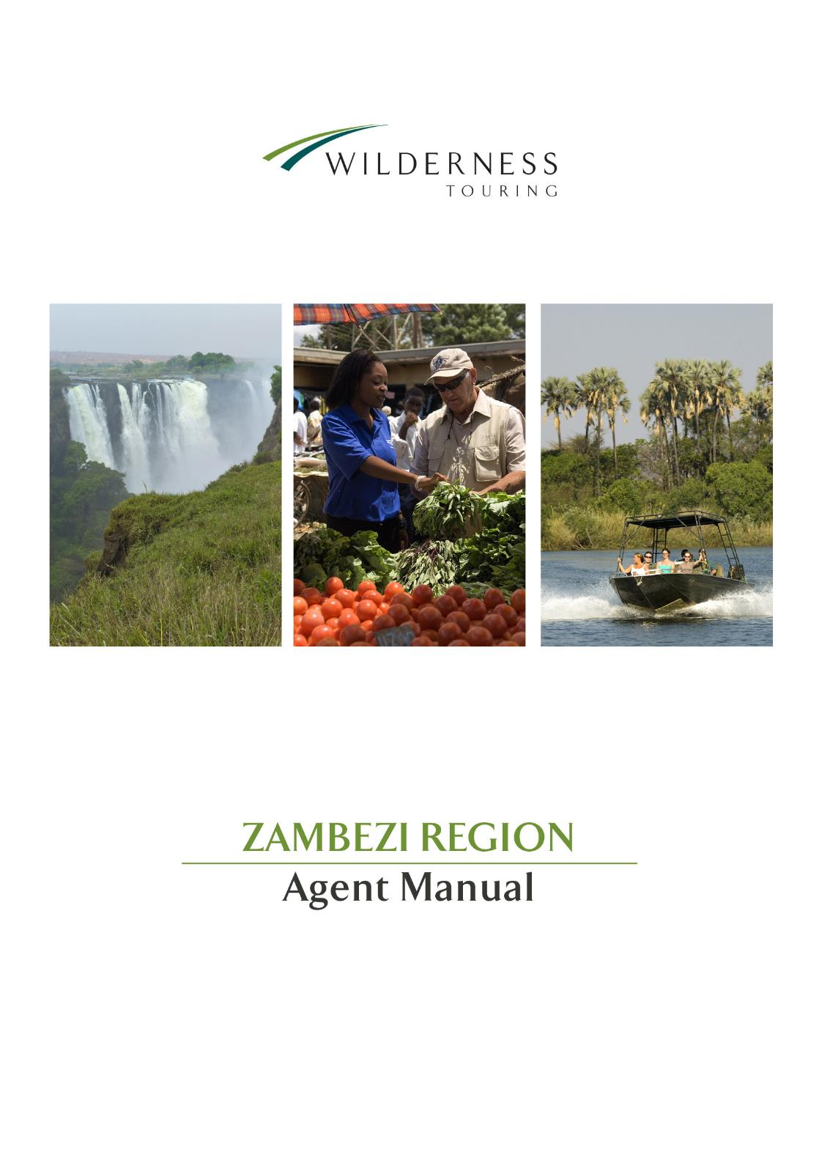

**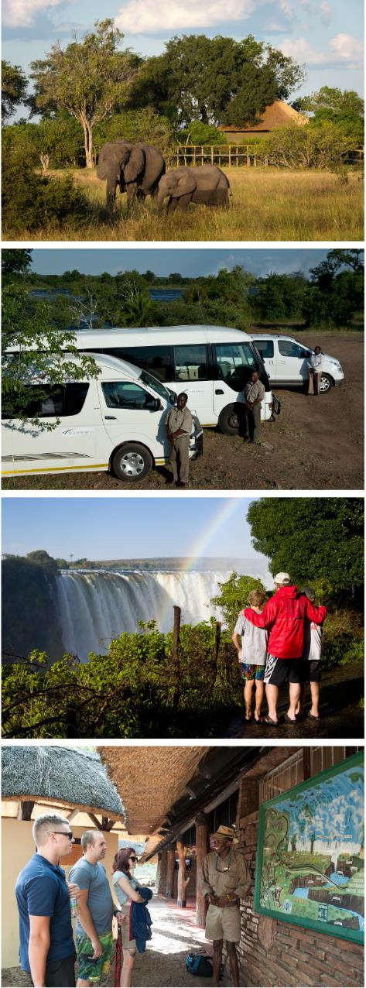Agent Manual Index**

1. **About Wilderness Safaris**
2. **Our Vehicles**
3. **Victoria Falls – Zimbabwe**
4. **Livingstone – Zambia**
5. **Harare – Zimbabwe**
6. **Botswana**
7. **Terms & Conditions**

**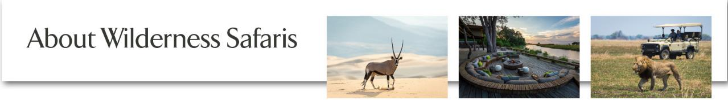**

Wilderness Safaris is an ecotourism company dedicated to responsible tourism in southern Africa, striving to ensure the protection of Africa’s spectacular natural heritage while sharing the benefits with its people.

In operation since 1983, Wilderness Safaris owns, markets and operates more than 50 camps and safaris in eight African countries – Botswana, Kenya, Namibia, Rwanda, Seychelles, South Africa, Zambia and Zimbabwe. In this way it offers its guests private access to 2.5 million hectares (6 million acres) of Africa’s finest wildlife reserves, while remaining fiercely committed to protecting our planet’s precious natural and cultural resources.

Aside from our camp portfolio, Wilderness Safaris also has a tour operating and transfer business, with offices, vehicles and guides in Victoria Falls and Cape Town.

Recognising that conservation is as much about people as about the environment, the company has pursued important goals through its Children in the Wilderness programme, as well as through the Wilderness Wildlife Trust, both of which have helped change the face of nature-based tourism in Africa.

Wilderness Safaris firmly believes that its single most important achievement to date is to have built a sustainable business model that does not compromise environmental principles and which helps build sustainable conservation economies in the rural areas in which we operate.

**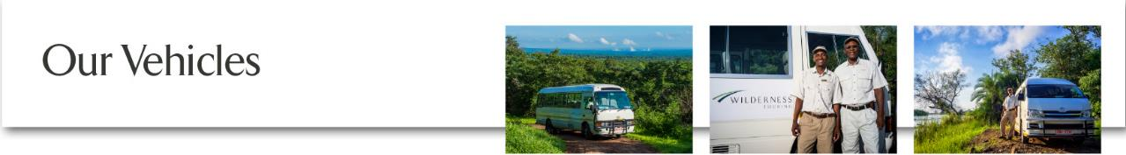**

Our vehicle fleet consists of the following:

# Zimbabwe

2 x Mitsubishi Rosa Fusos, 21 seater air-conditioned buses

1 x Mercedes Benz MCV, 25 seater air-conditioned bus

3 x Toyota Quantum, 13 seater air-conditioned mini buses

2 x Toyota Quantum, 5 seater air-conditioned mini buses

2 x Hyundai, 6 seater air-conditioned buses

5 x Toyota Coaster, 20 seater air-conditioned buses

# Zambia

1 x Toyota Coaster, 20 seater air-conditioned buses

2 x Mitsubishi Rosa Fusos, 21 seater air-conditioned buses

3 x Toyota Quantum, 16 seater air-conditioned mini buses

All pick-up times are arranged to tie in with flight departures, border meetings and scheduled tours. Our guides work to this timetable, collecting clients from each hotel en route to their intended destination.

Transfers can be booked either on a seat-in-coach basis, or the private hire of an entire vehicle. Please note that a minimum number of guests must be booked for private transfer bookings, and a minimum charge applies for some long-haul transfers. Please refer to your rates sheet for more information.

***Transfer changes*:** We often get clients phoning the night before or even on the day of travel to change their pick-up time. **Please note that should we have a vehicle available at the requested time, their reservation will then become a “private transfer” and clients will be charged accordingly.** **Guests will be required to pay the guide before departure and if the transfer is to the airport for a departing flight, payment must be in cash.** Wilderness Safariswill not be held responsible for clients who miss their flight due to a transfer time change, however we will advise clients accordingly if we feel they are not giving themselves enough time to check in.

**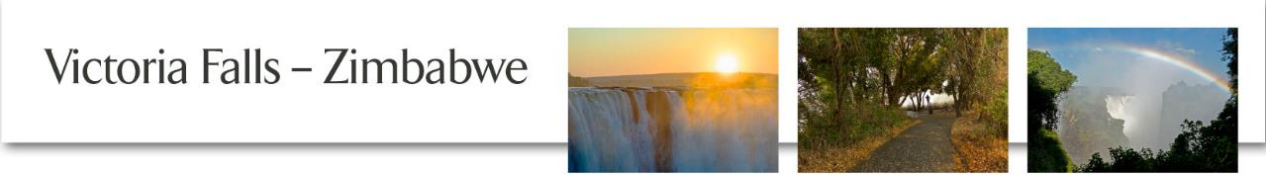**

# Transfers: Airport to Victoria Falls Town

All our transfers are conducted in minibuses and coaches. Guides will personally meet clients with a name board clearly identifying the guest’s name or group name. On the journey to town, guests are given a brief but informative commentary on the area, places to visit and items of special interest. The transfer takes approximately 20 minutes.

On arrival, guests are given a Welcome Pack containing the following:

* A welcome letter
* An itinerary giving them details of pick-up times for their return journey and any tours they may have booked with us.

## Hwange Transfers – minimum 4 people

Please allow 2½ - 3 hours for this journey. Hwange Safari Lodge and Main Camp are approximately 180 km from Victoria Falls.

## Inter-Hotel/Town Transfers – minimum 2 people

This service is available between 07h30 and 22h30 should clients need to be transferred between hotels, restaurants, and attractions.

### Tour of the Victoria Falls

[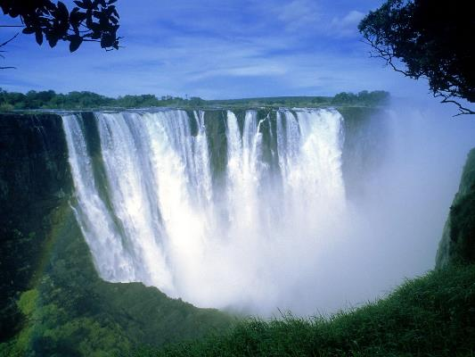](http://www.google.co.zw/url?sa=i&rct=j&q=&esrc=s&frm=1&source=images&cd=&cad=rja&uact=8&docid=UOAxGSxpUAwcnM&tbnid=fIFeCKPuYlHiNM:&ved=0CAUQjRw&url=http://hdwallpappers.com/victoria-falls-zimbabwe-africa-wallpaper/&ei=m4xHU__MN6nK0AXAu4GYBQ&psig=AFQjCNF3Di3R58QF__ae4rNFEYCUmr1eyQ&ust=1397284341026705)This tour is conducted in the morning and afternoon. En route, clients may be taken past the “Big Tree” where they may stop and take photos. Clients will be accompanied through the rainforest by one of our qualified guides who will provide a brief history of the Falls as well as detailing the flora, fauna and other points of interest. Guides are also happy to assist clients with photographs whilst visiting this most spectacular of waterfalls. Raincoats are provided when needed.

*Departure: 08h30 /14h30*

*Duration: 2 hours*

*Minimum 2 / Maximum N/A*

*No age restriction*

### Lunar Rainbow Tour

Lunar rainbows, also known as ‘moonbows’, are rainbows that occur at night, created by the light of a full moon refracting through water particles. It is one of the most impressive sights of Victoria Falls, which is one of only a very limited number of places around the world where lunar rainbows occur. Only visible during full moon when water level is high.

Minimum 2 / Maximum N/A

No age restriction

### Zambian Tour of the Falls

Clients are transferred from their hotel in Victoria Falls town across the border, and to the entrance of the Zambian rainforest. Here, they meet up with a Zambian guide who will escort them around the Falls, sharing facts and history along the way. Clients are also given the opportunity to enjoy curio shopping in the adjacent open-air markets before returning to Zimbabwe.

*Departure: 08h30 / 14h30*

*Duration: 2 ½ hours*

*Minimum 2 / Maximum N/A*

*No age restriction*

### Tour of the Zimbabwe and Zambian Falls – Half day

The tour starts off at the Zimbabwe rainforest with one of our qualified guides who will provide a brief history of the Falls themselves as well as detailing the flora, fauna and other points of interest. Guests then cross the border and enter the Zambian rainforest. From here, they meet up with a Zambian guide who will escort them around the Zambian Falls, sharing facts and history along the way.

*Minimum 2 / Maximum N/A*

### Zambezi Nature Sanctuary and Crocodile Ranch

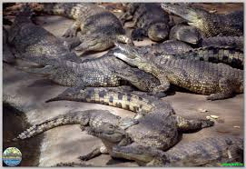This morning or afternoon guided tour stops at the “Big Tree” for a convenient photo opportunity en route to the Sanctuary. The Sanctuary and Ranch offers clients a unique insight into the life of a Zambezi crocodile, and is also home to a variety of wild animals including lion and ostrich. In the hatching season, clients may even hold a baby crocodile, and as this is a commercial farm, various crocodile by-products are on display and for sale in the form of gifts and souvenirs at the Ranch Gift Shop. Tours of the workshop are available should guests be interested in seeing how these products are made.

*Opening hours: Mon-Sun 08h00 – 16h30*

*Tours are conducted hourly*

*Feeding times: 11h15 every day and 15h45 every day*

*No age restriction*

### Mpisi Village Tour

Clients are taken to an authentic rural village approximately 20 km from Victoria Falls town where they are given the opportunity to watch local villagers going about their daily tasks. The tour enables guests to experience rural life first hand by visiting homes, watching the fields being tended and possibly getting the chance to help in some of the day-to-day chores.

*Duration: 2 hours*

### Tour of Victoria Falls and Mpisi Village – Half day

Enjoy both the Falls and Mpisi Village together. Guests will be accompanied through the rainforest by one of our qualified guides who will provide a brief history of the Falls themselves as well as detailing the flora, fauna and other points of interest. Then guests are taken to an authentic rural village approximately 20 km from Victoria Falls town where they are given the opportunity to watch local villagers going about their daily tasks. The tour enables guests to see rural life first hand by visiting homes, watching the fields being tended and possibly getting the chance to help in some of the day-to-day chores.

*Departures: 08h30 / 14h30*

*Duration: Approximately 3 to 4 hours*

*Minimum 2 / Maximum N/A*

*No age restriction*

### Steam Train

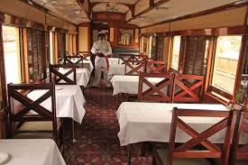The train offers a variety of memorable trips across the historic Victoria Falls bridge and into neighbouring Zambezi National Park, all commencing from Victoria Falls Station. Marvel at a spectacular African sunset aboard our authentic steam train while indulging in gourmet food and chilled refreshments. The train stops halfway across the bridge on every run, giving guests a breathtaking opportunity to wander along this impressive landmark or to relax in the luxurious lounge cars.

This beautifully restored steam train has a 1954 class 14a steam locomotive, dining cars and first class coaches. It can carry up to 220 passengers, who are attended by our enthusiastic and well-trained staff. An African steam safari will appeal to those who want to appreciate the beauty and history of this part of the world.

### Sunset Bridge Run

Embark on a dramatic two-hour sunset trip across the Victoria Falls Bridge. Depart from the Victoria Falls Station, (opposite the Victoria Falls Hotel), and sip on champagne while the train stops halfway across the bridge. Unwind in one of the luxurious lounge cars or stroll along the majestic bridge while experiencing unparalleled views of Victoria Falls and the turbulent water in the gorge below. This impressive trip will also take you briefly through the neighbouring Zambezi National Park. Champagne, gourmet canapés and drinks are served on the tour.

*Duration: 2 hours*

*Departure times: Between 16h30 – 17h00 depending on season to capture sunset*

*50 minimum or for exclusive use of the train: 80 passengers*

*All children must be accompanied by an adult when travelling on the train*

### Moonlight Dinner Run

This unique dinner experience begins in the same manner as our Sunset Bridge Run, embarking on a sunset journey to the middle of the Victoria Falls Bridge. Savour chilled refreshments and gourmet canapés, stroll along the bridge, and relax in elegant carriages as the sun sets over the magnificent Victoria Falls. The slow, luxurious journey continues into the Zambezi National Park where one can partake of a romantic three-course dinner under the African night sky or in the comfort of our timeless lounge cars. A roaring bonfire for cooler nights will keep away the chill, while a soft, cool breeze refreshes on warmer summer nights. A three-course dinner including champagne and all drinks is served on this tour.

*Departures: Between 16h30 – 17h00*

*Duration: Approximately 5 hours*

*40 minimum or for exclusive use of train: 50 passengers*

*Dinner on board: Maximum 64 passengers*

*All children must be accompanied by an adult when travelling on the train*

***Please note*** the tour rates do not include any visa fees or customs duties guests may incur at the border. The customs and immigration officials do however board the train for your convenience while carrying out these formalities.

### ANd9GcRCqMz1TEhbTgXtD_yTgNwfYvYz6zHR90Gmpl3T_96SR9Ejr1dtdQTram Morning or Afternoon Bridge Run

Steeped in history, the Victoria Falls Tram Bridge Tours are a unique journey into the adventure and romance of a bygone age. Both morning and sunset tours begin with a stroll down the red carpet linking the iconic 108-year-old Victoria Falls Hotel to the train platform at Victoria Falls Station. After refreshments, the 19th century-style tram begins its gentle, 20-minute meander through the vibrant town of Victoria Falls, looping through classic African bush often inhabited by wildlife and passing by the Victoria Falls rainforest. Its final destination is right in the middle of the Victoria Falls Bridge which straddles the border dividing Zimbabwe and Zambia.

*Duration: 2 hours*

*Morning: Departs – 10h00 / Returns to Victoria Falls Hotel – approximately 12h30*

*Afternoon: Departs 16h30 – 17h00 depending on season to capture sunset*

*50 minimum or for exclusive use of the train: 80 passengers*

### The Boma – Place of Eating

This is not just another ethnic restaurant but a unique cultural experience. Excellent cuisine, including a variety of game meats and traditional Zimbabwean dishes, is accompanied by entertainment throughout your meal, such as traditional dancers, a Sangoma (storyteller) and a local witchdoctor who is available for fortune telling. Hair braiding (up to three braids) and face painting is available and free of charge.

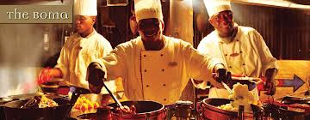

Restaurant hours: 19h00 - 22h00

Traditional dancing begins: Between 19h45 and 20h00

Drumming show begins: 20h45

### Mama Africa

Mama Africa serves traditional African food with a twist in an unusual ambience. Tourists can enjoy both pub meals and regular meals and the dress code is casual. Live music is played in the evenings to enhance the mood of the restaurant.

*Restaurant hours: 10h00 – 22h30 seven days a week*

### Curio Shopping

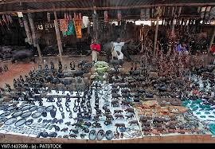A daily tour designed for enthusiastic shoppers on the lookout for bargains or keen to try their hand at the African system of ‘barter-trade’. The tour visits open-air markets and crochet halls as well as a variety of galleries and shops selling stone sculptures and authentic African art.

*Duration: 2 hours*

## RIVER CRUISES

A boat cruise is a superb way to relax and enjoy the beauty of the Zambezi River. Clients have the opportunity to see a variety of game including hippo, crocodile, and elephant and sometimes even rhino in their natural environment, as well as enjoy the many different bird species. Below are a variety of cruises that guests can opt for.

### Breakfast Cruise

This cruise is perfect for the early riser and a wonderful opportunity for keen birders. Includes a cooked breakfast, fruit, muffins, tea and coffee and orange juice. This is a beautiful time of day to be on the river as there are often fewer boats, giving one a real sense of privacy – excellent value for money.

*Departure: Between 07h00 – 07h30 to 09h00 – 09h30 daily*

*Duration: 2 hours*

*Minimum 10 / Maximum 60*

*No age restriction but all children must be accompanied by an adult*

### Lunch Cruise

Lunch includes a variety of salads, fresh bread rolls, stir-fried chicken, beef and vegetables, desserts, tea and coffee, beer, wine and soft drinks. All food is cooked on board on a *skottelbraai* so it is served fresh and hot. (Please ensure we are informed in advance of any vegetarian or other dietary requirements.)

*Departure: 12h00 – 14h00 daily*

*Duration: 2 hours*

*Minimum 10 / Maximum 60*

*No age restriction but all children must be accompanied by an adult*

### Sundowner Cruise

This popular sunset cruise includes finger snacks, beer, wine, champagne and soft drinks. There are great photo opportunities against often spectacular African sunsets.

*Departure – winter: 16h00 – 18h00 daily; summer: 16h30 – 18h30 daily*

*Minimum 2 / Maximum N/A*

*No age restriction but all children must be accompanied by an adult*

### Jet Boat Sunset Cruise

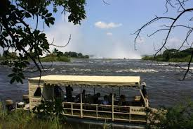A cruise that will take you where others want to go. Experience this unique and close-up exploration of the islands situated on the Upper Zambezi, just above the Victoria Falls. Relax on the boat enjoying snacks and beverages whilst viewing the rising spray from one of the Natural Wonders of the World. Visit parts of the river previously only accessible by canoe. Meander gently through the cluster of islands and discover the secret hideaways of hippo and elephant as well as enjoy the fascinating flora and fauna. A truly soulful journey full of ambience, highly recommended for photographers and naturalists.

*Departure – winter: 15h30 – 18h00 daily; summer: 16h00 – 18h30 daily*

*Minimum 2 / Maximum N/A*

*No age restriction but all children must be accompanied by an adult*

### Dinner Cruise

While sunset cruise boats return to shore we remain on the mighty Zambezi to dine and enjoy the solitude of this majestic river. This is a nightly cruise option and can also be booked for private group functions. There is a special magic to dining at night on the river with the sights and sounds of the mainland and the rhythmic thunder of the Falls in the background. The night sounds of myriad insects and night birds as well as grunting hippos lend an almost surreal quality to the three-course dinner.

*Departure: Between 16h30 – 17h00*

*Includes sunset cruise, full local bar, light snacks and three-course dinner*

*No age restriction but all children must be accompanied by an adult*

***Please note*** that dietary requirements must be provided. The cruise offers local drinks which are included in the price. Specials can be requested at a surcharge.

### Jetty Dinner

Eat dinner by the light of the moon on the Zambezi River. A delicious three-course dinner is served while you sit alongside the river bank listening to the sounds of the river and the bush. The setting is at the jetty right on the river.

*Departure: 19h00 – 21h30*

*Duration: Approximately 2 ½ hours*

*No age restriction but all children must be accompanied by an adult*

### The Ra-Ikane Sunset Cruise

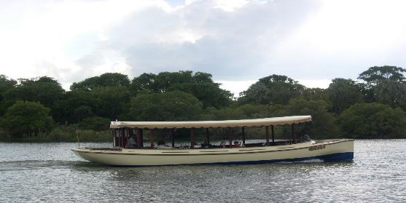The Ra-Ikane is a small luxury cruise boat that is outfitted to suggest, in exquisite detail, the ambiance of a bygone era, paying tribute to Ra-Ikane, one of the guides who first led David Livingstone to the Victoria Falls. Period décor, historic memorabilia, fine cuisine and refreshments characterise a level of comfort and grace unsurpassed on the Zambezi. High tea, snacks, imported drinks and wine are served on the boat.

*Departure – winter: 16h00 – 18h00 (01 May – 31 August); summer: 16h30 – 18h30 (Jan – April & Sep – Dec)*

*Duration: Approximately 2 hours*

*Maximum of 12 passengers*

*All children must be accompanied by an adult*

### Bird Watching Cruise

This is a wonderful way to start the day. A tranquil boat ride departs for an amazing two-hour slow cruise along the islands on the lookout for all manner of birds that live in this river system. A choice of tea, coffee and soft drinks is served with muffins and biscuits on this morning activity.

*Departure – winter: Between 06h00 / 06h30 – 08h00; summer: Between 06h30 / 7h00 – 09h00*

*Duration: 2 hours*

*Minimum 2*

*No age restriction*

### The Zambezi Explorer Cruise Boat

[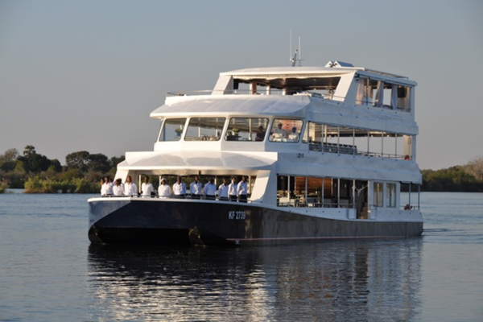](http://www.google.co.zw/url?sa=i&rct=j&q=&esrc=s&frm=1&source=images&cd=&cad=rja&uact=8&docid=baIl7Wsm3zP9WM&tbnid=ZL2Yon_yCFqKtM:&ved=0CAUQjRw&url=http://www.skyscrapercity.com/showthread.php?t=1663779&page=2&ei=AKJHU5_oBaqo0QWRloDwCA&psig=AFQjCNEE35yDH2abxkFE3tlSZH4cQDvHQA&ust=1397289823328499)The flagship *Zambezi Explorer* is a 140-seater boat and is the first of its kind on the Zimbabwe side of the Falls. The vessel has two lower decks as well as the exclusive signature deck that seats 30 passengers. Facilities on the signature deck include a fully-stocked bar, wheelchair, wheelchair toilet and Wi-Fi. It also houses a kitchen where fresh-cooked food is prepared. The cruise rate includes canapés and beverages. A nanny is available on request.

Summer period (September – April) pick up time: 16h15

Winter period (May – August) pick up time: 15h45

## WHITE WATER RAFTING

The rapids on the Zambezi River are officially defined as Grade 5 by the British Canoe Union (Grade 6 being commercially un-runnable). Clients should be reasonably fit for this activity, as there is a fairly steep walk into and out of the Batoka Gorge as well as the white water rafting activity itself. Tea, coffee and biscuits are served in the morning at check in, after which clients are taken to the Gorge for their safety briefing before the day’s activity commences. Depending on the activity booked, a light lunch is either served in the gorge between rapids (full day), or at the top of the gorge (half day). Clients booked for a full day will continue rafting in the afternoon and can expect to be returned to their hotels at 15h00 (high water) and 17h00 (low water). Due to the nature of this activity, clients should be warned to leave their valuables and personal effects safely locked up at their hotel.



### Low Water Rafting

Daily (August – December); covers Rapids 1 – 19

Minimum 4 / Maximum N/A

Check-in time: 07h00

Return to Victoria Falls: 15h00

Snack: Fruit snack served in the gorge at Rapid 11

Lunch: Lunch at the top of the gorge at Rapid 19

Minimum age: 15 years (this is flexible and at management’s discretion, i.e. if mature, strong and can fit into a lifejacket properly, younger children are sometimes accepted)

### High Water Rafting

Daily (January – July); covers Rapids 11 – 24

Minimum 4 / Maximum N/A

Departure: 07h00

Return to Victoria Falls: 14h30

Lunch is served at the top of the gorge at the end of the activity

Minimum age: 15 years (this is flexible and at management’s discretion, i.e. if mature, strong and can fit into a lifejacket properly, younger children are sometimes accepted)

### White Water Rafting – Multi-Day

The spectacular Batoka Gorge is the highway for our Multi-Day Rafting trips. After the wildest one-day run in the world, our experienced guides continue on down the Zambezi River offering two-and-a-half to five-day journeys. All equipment is taken on the rafts and camp is set on remote sandy beaches only accessible by raft. The river varies from long peaceful stretches to renowned and wild Grade 5 rapids such as “Ghostrider”, “Chimamba” and “Moemba Falls”.

Departure: Varies

Duration: 2 Night, 2 Day or 4 Night, 5 Day trips

Minimum 4 / Maximum N/A

Minimum age: 15 years (this is flexible and at management’s discretion, i.e. if mature, strong and can fit into a lifejacket properly, younger children are sometimes accepted)

### Rafting & River Boarding Combination – Full day

Take on the meanest Zambezi rapids with flippers and a boogie board. Challenge the huge rapids and yourself. This product combines the best of rafting with the challenge of spectacular river boarding. This product runs during low water only. Not all the rapids are suitable for river boarding so the trip offers both rafting and river boarding in a full day excursion, from Rapids 1-19, depending on the water level and where the best surfing spots are at the time. Clients must be good swimmers and understand and speak English for safety reasons.

Departure: Pick up from hotels is between 06h40 and 07h00 and return at approximately 16h30.

Minimum 2 / Maximum 20

Minimum age: 15 years

All trips are totally dependent on water levels and it is important that clients are aware of the seasonal nature of the products:

High water season: approximately January to July

Low water season: (peak season) approximately August to late December

## Upper Zambezi Canoeing

After a transfer from your hotel at 07h00 into the Zambezi National Park, you can enjoy a continental breakfast on the banks of the Zambezi before setting off for the day. Drift through the channels of the upper Zambezi and thrill to the ever-so-slight turbulence of the more placid rapids, just above Kandahar Island. The professional canoe guide orientates you through the flora, birding and animal life all spotted from within the unique inflatable canoes. You may be fortunate to spot a martial eagle or watch tigerfish leaping and Cape clawless otters playing in the shallow waters.

On this trip clients paddle their own canoes, following their qualified Canoe Guide as he leads the way, stopping for a light picnic lunch on an island before making their way to the disembarking point at approximately 14h00.

*Minimum participants: 2*

*Minimum age: 7 years (this is flexible and at management’s discretion, i.e. if mature, strong and can fit into a lifejacket properly, younger children are sometimes accepted)*



This trip includes:

* Courtesy transportation from all major lodges and hotels within the Victoria Falls town centre to the jetty
* Amazing photo opportunities
* Qualified guides who carry a first-aid kit and radio for communication
* Refreshments served on an island or in the canoes
* Breakfast and picnic lunch

## HIGH-WIRE ADRENALIN ACTIVITIES

A collection of seven mind-blowing extreme adrenalin activities set on the edge of the Batoka Gorge, 300 m from the Victoria Falls. There is something for every age, level of madness and courage.

### Bungee Jumping

Located on the Victoria Falls Bridge, you will get to experience 111 metres of sheer adrenalin, as you plummet towards the mighty Zambezi in four seconds of free-fall, at speeds of up to 120 km/h. You can either do a solo or tandem jump. After the jump a recovery operator, lowered down to the jumper, then attaches a recovery line to the body harness of the jumper. Both the jumper and operator are then winched back on to the catwalk below the bridge. During this process, the jumper is pulled into an upright position. The jumper is then attached to a safety line on the catwalk and checked by a senior jumpmaster before being escorted onto the bridge road-deck.

### The Bridge Swing

This is an opportunity for an amazing ‘big air’ experience and sheer adrenalin in front of the Victoria Falls. This is without doubt one of the most spectacular swings in the world! The swing is made on two 65 metre static line climbing ropes attached to a 10-tonne safe working load cable by a steel clamp. A 1 m-bungee cord is positioned on the clamp to provide the swinger with a smoother ride and more comfortable swing. Swingers remain in a seated position throughout the recovery and can enjoy the view of both the Falls and the bridge. The swinger is recovered to the winch platform and then walks out in the same manner as the bungee jumpers to emerge on the Zambian side of the bridge.

### Bridge Slide

The Bridge Slide offers a remarkable opportunity for sheer fun in front of the Falls. The slide begins on the Zambian bank of the gorge and ends on the Zimbabwean side at the bridge. As the clients slide from the gorge towards the bridge, they enjoy an incredible view of the Falls and the bridge during this amazing big air experience. The slide platform consists of two areas, one of which is available for viewing purposes and the other is restricted to the slider/s and the crew. The clients are attached to the cable using a twin-bearing inbound pulley that can take up 1.5 tonnes. Due to the nature of the catenary (the slack in the cable) the slider will come to a slow stop on the upper part of the cable. Before the slider begins to slide backwards, a recovery operator on a separate slider will meet the client and attach himself to the client’s slider. The recovery operator is then retrieved along with the client back towards the bridge platform. Once the client has been detached from the slider, they are assisted over the railing to join the swingers and jumpers on the walk out.

### Gorge Swing

Imagine a child's swing in the playground... now imagine a giant swing 95 m long and 120 m above the river with a 70 m free-fall before you begin swinging! The high wire is suspended across the gorge at the point where it is 316 m wide and 120 m deep. A harness is attached to the jumper and then the jumping ropes, the other end of which is pivoted to the middle of the cable. The jumper leaps off the edge of the gorge, free-falling about 70 metres before going into a 95 m long pendulum-type swing.

*Departure: On request, from hotels and B&Bs in Victoria Falls town*

*Minimum / Maximum participants: N/A*

***Restrictions:*** The age limit is 14 years and minimum weight 40 kg on this activity; however, at management’s discretion children may be required to travel in a double harness with an adult. Parents or guardians of any child under 16 must be present and available to sign an indemnity on the child’s behalf. Management retains the right to turn a child away should they feel the child is not able to cope with the experience in any way. There is no maximum age limit.

### The Zip Line

Imagine the adrenalin rush of travelling at a speed of 106 km/h, hurtling 425 m across the Batoka Gorge, while suspended 120 m above the breathtaking beauty of the Zambezi River below. As the river zigzags down the Batoka Gorge, our cable is suspended from one side to the other. For this activity you are harnessed and attached to a pulley, then launched over the edge picking up speed as you descend over the water until reaching a speed of 106 km/h. This is the longest zip line ride in the world.



*Departure: On request, from hotels and B&Bs in Victoria Falls town*

*Restrictions: – The age limit is 4 years old and minimum weight 40 kg on this activity; however, at management’s discretion children may be required to travel in a double harness with an adult. Parents or guardians of any child under 16 must be present and available to sign an indemnity on the child’s behalf. Management retains the right to turn a child away should they feel the child is not able to cope with the experience in any way. There is no maximum age limit.*

### The Flying Fox

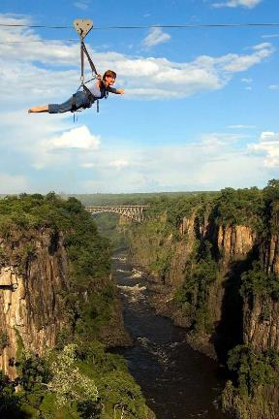The Flying Fox is all about taking a running jump into thin air over a chasm and soaring horizontally over the roiling Zambezi River below. The Batoka Gorge at this point is 200 m wide and 120 m deep. This is a great appetiser before trying the zip line or gorge swing.

*Departure: On request, from hotels and B&Bs in Victoria Falls Town*

*Restrictions: – The age limit is 4 years old; however, at management’s discretion children may be required to travel in a double harness with an adult. Parents or guardians of any child under 16 must be present and available to sign an indemnity on the child’s behalf. Management retains the right to turn a child away should they feel the child is not able to cope with the experience in any way. There is no maximum age limit.*

**The Adrenalin Half-Day**

Morning: 08h30 – 12h30

Afternoon: 13h30 – 16h30

This half-day activity includes any of the following three activities**.** Also included are transfers to and from Victoria Falls town.

* ***Bungee Jump:*** Located on the Victoria Falls Bridge, clients experience 111 metres of pure adrenalin, plummeting towards the mighty Zambezi in four seconds of free-fall, at speeds of up to 120 km/h. Available as a solo or tandem jump.
* ***Bridge Swing*:** The swing is made on two 65 m static line climbing ropes attached to a 10-tonne safe working load cable by a steel clamp. A 1 m bungee cord is positioned on the clamp to provide the swinger with a smoother ride and more comfortable swing.
* ***Bridge Slide:*** The slide begins on the Zambian bank of the gorge and ends on the Zimbabwean side of the bridge. As the client slides from the gorge towards the bridge, they enjoy an incredible view of the Falls.

### Victoria Falls Canopy Tour

The Victoria Falls Canopy Tour offers a network of slides, trails and rope bridge walkways within the canopy of the hardwood forest of the Zambezi gorges. This exciting and scenic activity offers amazing views of the turbulent rapids, the Victoria Falls Bridge and spray of the Falls. It offers family fun and a unique bird’s-eye view of one the seven Natural Wonders of the World. Forest birdlife can include Knysna and purple-crested turacos and peregrine falcons. The tour consists of nine different slides, varying in length (with the longest being approximately 85 m and the shortest being 40 m) and one cable bridge walkway. The friendly and experienced staff provides a detailed safety briefing before the beginning of a tour, taking clients step by step through the upcoming adventure. There are two guides on each tour.

Duration: 2 ½ hours

Minimum 2 / Maximum 8

No Age Restriction

## SAFARIS AND GAME DRIVES

Please note that the Victoria Falls National Park may be closed during the rainy season if the roads are deemed to be unsafe for travel.

### Morning Drives

Early morning drives are conducted in open safari vehicles accompanied by a qualified game guide. Clients may enjoy a variety of sightings from animals and birds to insects and trees before returning to their hotel at approximately 09h00. Breakfast is not included on this activity.

*Departure: Early Morning*

*Minimum 2 / Maximum 14*

*Minimum age: 4 years old and all children must be accompanied by an adult*

### Afternoon Drives

This activity is similar to the morning drive and includes soft drinks only. Clients are returned to their hotel by 18h30.

*Departure: 15h00*

*Duration: 3 ½ hours*

*Minimum 2 / Maximum 14*

*Minimum age: 4 years old and all children must be accompanied by an adult*

### Elephant-Back Safaris

Clients are driven approximately 16 km to The Elephant Camp for an interactive and very personal elephant experience, inclusive of a 1½ hour elephant-back ride. The morning safari includes a full English breakfast, while snacks and sundowners are served on the afternoon safari.

### Sunrise Elephant-Back Safari

Take an extraordinary and exhilarating journey along the edge of the Zambezi gorges following ancient game trails. Seated comfortably on the back of a habituated elephant, guests experience an age-old tradition whilst silently exploring the majestic grasslands of Victoria Falls National Park and marvelling at the spectacular scenery of the Masuwe River as it plunges 120 m into the Zambezi River below. Be witness to this mutually enriching and rewarding relationship between human and elephant in a modern-day Africa. Sunrise safaris are run daily, promising much more than just a game-viewing experience; it offers a closer insight into the world's largest land mammal, the African elephant. The morning safari includes a full English breakfast.

Departure: Between 06h00 and 06h20 (summer) and between 06h30 and 07h00 (winter)

Duration: 3 hours

Minimum 2 / Maximum 16

Restrictions: Children below the age of 5 years are unable to participate in the elephant-back safaris. A guardian must accompany children between 6 and 18 years.

### Sunset Elephant-Back Safari

Sunset safaris are run daily, promising much more than just a game-viewing experience; rather, it offers a closer insight into the world's largest land mammal, the African elephant. The afternoon safari includes snacks and sundowners.

*Departure: Between 15h00 and 15h20 (summer) and between 14h30 and 15h00 (winter)*

*Duration: 3 hours*

*Minimum 2 / Maximum 16*

*Restrictions: Children below the age of 5 years are unable to participate in the elephant-back safaris. A guardian must accompany children between 6 and 18 years.*

### Elephant Interaction and Dinner at the Wallow

A welcome drink is served upon arrival at the Elephant Wallow, which is part of the Wild Horizons Wildlife Sanctuary and Orphanage, situated in the magnificent Victoria Falls National Park. A presentation follows, giving guests more information about the elephants in the herd. Following the presentation the guests are divided into small groups and then have the opportunity to interact with the adult and young orphaned elephants.

The elephants retire to their stables at approximately 18h30; the guests then have sundowner drinks on the deck overlooking the Masuwe River. During this time the guests interact with the elephant management team. A lovely dinner is served, followed by the group’s return transfer to Victoria Falls town.

*Departure: Activity begins at 16h30*

*Minimum 20 / Maximum 80*

### Batoka Gorge Dinner

The setting for this dinner is the stunning Lookout high up on the spectacular cliffs of the Batoka Gorge between the Victoria Falls Hotel and Victoria Falls Bridge, above Rapids 3 and 4. The venue caters for groups of between 10 and 30 guests. With the dramatic gorge below, the spectacular spray of the Falls and the majestic Victoria Falls Bridge beyond, this a dinner never to be forgotten!

*Departure: Between 17h00 – 17h30*

*Minimum 10 / Maximum 30*

### Walking Safari – Half Day

Venturing further into the Zambezi National Park, this walk is combined with a game drive in a suitable walking area of the park. Whilst following in the footsteps of elephants, guests are able to learn about a variety of aspects of the wildlife in the area, as the professional guide shares his/her knowledge and experiences with them. Morning walks include tea, coffee, mineral water, cheese and tomato sandwiches and fruit. Afternoon walks include soft drinks, beer, mineral water and snacks.

*Departure: Morning (winter) 06h15 / 06h30; Afternoon (winter) 14h00 / 14h30*

*Duration: 4 hours*

*Minimum 2 / Maximum 18*

*Minimum age: 12 years*

### Morning or Afternoon Game Drive

Visiting the 57 000-acre Zambezi National Park, these drives set off either in the early morning or mid-afternoon. Using an open four-wheel-drive vehicle, the game drive allows guests to discover many interpretations of the bush, related to them by our suitably qualified guides. Morning drives include tea, coffee, mineral water, cheese and tomato sandwiches and fruit. Afternoon drives include soft drinks, beer, mineral water and snacks.

*Morning departures: Between 06h00 and 06h15*

*Afternoon departures: 14h00*

*Minimum 2 / Maximum 40*

*Minimum age: 4 years*

### Bird-Watching Safaris

Catering for the keen bird-watcher, our safaris offer tailor-made trips that are crafted on which species guests want to see. Either by open safari vehicle, on foot or by boat we search for an array of species through a variety of habitats such as teak and mopane woodlands, grassland and riverine forest. Depending on seasonal conditions, species that can be seen include African skimmer, collared palm-thrush, rock pratincole, racket-tailed roller, western-banded snake-eagle, kori bustard, African finfoot and many others. Morning drives include tea, coffee, mineral water, cheese and tomato sandwiches and fruit. Afternoon drives include soft drinks, beer, mineral water and snacks.

*Departure times (summer): 06h15; 14h30*

*Departure times (winter): 06h30; 14h00*

*Duration: 4 hours*

*Minimum 2 / Maximum 18*

*No age restriction*

### Hwange Day Trip

Hwange National Park is one of the finest conservation areas in Zimbabwe and boasts an enormous variety of big and small game species and birdlife. The Park is 14 651 sq. km and is largely a Kalahari system with flat plains and natural pans. In the dry season, huge herds of buffalo and elephant can often be seen at the waterholes, while to date 25 predator species have been recorded in the Park as well as some 400 birds. This day trip from Victoria Falls by road is accompanied by a driver/guide.

*Departure: 06h00*

*Duration: Approximately 6 hours*

*Minimum 4 / Maximum N/A*

*No age restriction*

### Chobe Day Trip – Full Day

This tour departs daily to Chobe National Park in Botswana. Guests are transferred to the Kazungula border post where their Botswana guide will meet them. From here, they proceed straight to the Chobe River where they will spend the morning game viewing. Tea, coffee and biscuits are provided. The morning cruise ends around 12h30 and clients are then taken to the Chobe Safari Lodge on the banks of the river for lunch. After lunch guests board safari vehicles for an afternoon game drive in the Chobe National Park with the opportunity to observe an abundance of wildlife. Thereafter guests are taken back to the border and arrive back in Victoria Falls at around 18h30.

*Departure: 07h30*

*Duration: Approximately 10 hours*

*Minimum 2 / Maximum N/A*

*Minimum age: 4 years*

### Chobe Day Trip – Half Day

This tour departs daily to Chobe National Park in Botswana. Guests are transferred to the Kazungula border where their Botswana guide will meet them. Their morning activity can be either a game drive in Chobe National Park or a morning cruise on the river. Tea, coffee and biscuits are provided. Lunch at the Chobe Safari Lodge on the riverbank is optional and at an extra cost.

*Departure time: 07h30*

*Duration: Approximately 8 hours*

*Minimum 2 / Maximum N/A*

## ADVENTURE AND SAFARI PACKAGES

### Tick-It to Adventures

An exciting way to buy adventure activities with unrivalled choice and unbeatable value for money.

* **Tick-It to Adventure 1** (TTA1)   
  Enjoy a magnificent sunset cruise and your choice of any two Shearwater activities – plus any additional Shearwater product at a discount value.
* **Tick-It to Adventure 2** (TTA2)   
  A choice of any three Shearwater activities – plus any additional Shearwater product at a discount value.
* **Tick-It to Adventure 3** (TTA3)   
  Experience any five Shearwater activities in an adrenalin-pumping holiday to the Victoria Falls – plus any additional Shearwater product at a discount value.

### Shearwater’s Big Five Interactive Safari Packages

These packages offer a combination of amazing wildlife experiences in the Victoria Falls Private Game Reserve at great value. An Elephant Interactive Safari is a once-in-a-lifetime experience never to be forgotten. Ride, learn and interact with these majestic creatures. There is also the chance to search for the rest of Africa’s “Big Five”.

* A morning or afternoon Elephant Interactive Safari PLUS a rhino search
* Afternoon Elephant Interactive Safari PLUS a rhino search – plus a bush dinner

## Helicopter Rides

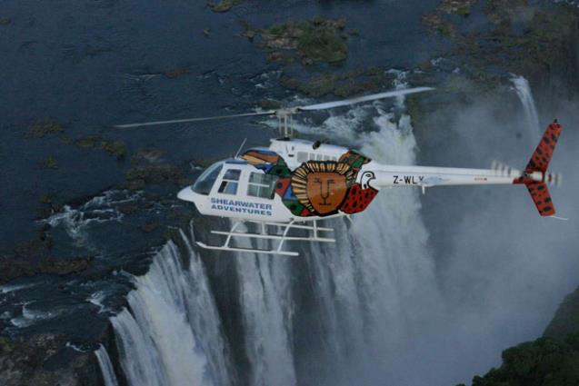These 13- and 25-minute flights depart regularly throughout the day and offer spectacular photographic opportunities. Clients are collected from their hotels 30 minutes prior to their flight departure and transferred to the helipad near the Elephant Hills Hotel. They are given a safety talk on arrival before the flight. The 13-minute Flight of Angels includes a flight over the majestic Victoria Falls, whilst the 25-minute Game Flight includes a flight over the Zambezi National Park.

### Flight of Angels: 13-minute flight

Minimum 3 / Maximum 10

### Zambezi Spectacular: 25-minute flight

Minimum 3 / Maximum 10

Departure: Throughout the day – turn-around time is 1 hour for the Flight of Angels and 1 ½ hours for the Zambezi Spectacular**.**

Maximum weight: 120 kg per person

No age restriction – all children must please be accompanied by an adult

Children under 3 years of age are flown free of charge sitting on the parent’s lap

All children over 3 are charged full price

The helicopters have modified window structures to accommodate all passengers for an optimal viewing experience.

* 2 x Bell Jet Rangers which can accommodate 4 passengers
* 1 x Bell Long Ranger which can accommodate 6 passengers

Note:

* Flights may be delayed by rain or heavy cloud cover over the Falls. In such situations, passengers will be asked to reschedule and if they cannot, a full refund is issued.
* Any confirmed booking cancelled with less than 24 hours’ notice prior to flight time or any no-shows will be subject to a 100% cancellation fee. This also applies to last-minute confirmed bookings.
* Any confirmed group booking (group is of at least 14) cancelled with less than seven days’ notice prior to flight time is subject to a 50% cancellation fee.

### Fish the Mighty Zambezi River – Three-hour, Half-day and Full-day Trips

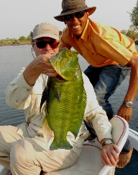Fish the mighty Zambezi River all year round for tiger, bream, nembwe and catfish – to mention just a few of the 75 known species found in the Zambezi River. We offer fly fishing, spinning, trolling and drift bait or live bait fishing from our pontoon vessel for a maximum of eight passengers. The trip is led by a professional fishing guide and all fishing equipment bait, food and beverages are included.

**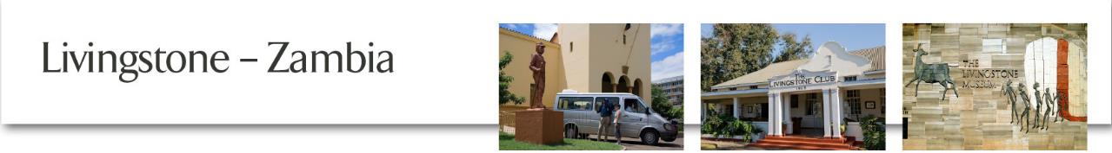**

Please note that clients will need their passports to enter Zambia. Visas can be purchased at the border, depending on nationality, and are for the client’s own expense.

## Tour of the Falls

From January to June, Zambia benefits massively from the increased water flow over the Falls, making it a spectacular viewing point. The rainforest has walkways that end up opposite the Danger Point. One of our experienced guides will collect guests and show them the Victoria Falls while telling them all about this spectacular natural phenomenon.

*Departure: 08h30 / 14h30*

*Duration: 1 ½ hours*

*Minimum: 2 / Maximum: N/A*

*No age restriction*

## Zambia Transfers – minimum 2 people

Clients will need their passports and where necessary, a visa to enter Zambia. Visa fees are not included in any of our rates, however clients can buy visas at the border and must pay the Department of Immigration directly.

Transfers are available in and around Livingstone from lodges, hotels and Livingstone Airport. We also offer transfers to and from hotels in Victoria Falls and the Victoria Falls Airport. The journey from Victoria Falls town to Livingstone town is approximately 30-45 minutes including border formalities.

### Fishing – Half, Full day

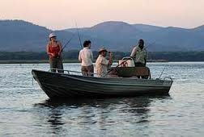

Our experienced guides will take you to the best fishing areas where your thirst for action can be satisfied. Over 75 species of fish swim in the waters of the mighty Zambezi with a quest to elude capture. One of these is rated by many anglers as “the finest sporting and fighting fish in the world” – the renowned tigerfish. Beers, soft drinks and mineral water are provided.

### Quad Bikes

The company currently operates 8 Honda TRX250 cc four-stroke quad bikes and two specially-designed quad bikes for children. These semi-automatic transmission vehicles were chosen for their low environmental impact with minimal decibel noise emissions and low lead fuel capability, which not only benefit the surroundings, but also enhance the serenity of the riding experience. There are two trails to choose from:

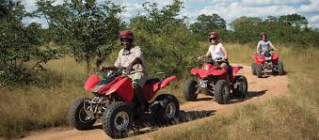

**Eco Trail Ride**

This is a fun trip taking you through the African bush, around bends, through ditches and over humps, with the possibility of encountering game along the way. The trip is approximately 1 hour with a refreshment break halfway through.

*Duration: 1 hour*

*Departure: 07h00 and every 2 hours thereafter*

*Minimum 4 / Maximum 6*

*Minimum age: 12 years*

**Village Trail Ride**

This ride, which can be custom-made according to the requirements of the clients, travels from Mukuni Village, past Machenje Village, then an exhilarating ride over a dune through dense bush to Sichilobe Village, followed by a drink stop. Participants then turn around and drive back.

*Duration: 2 hours*

*Departure: Can be custom-made to suit clients*

*Minimum 4 / Maximum 6*

*Minimum age: 12 years*

### Mukuni Village

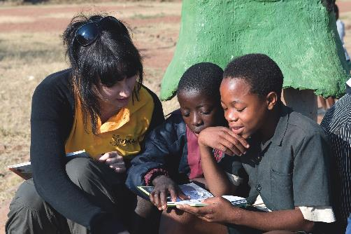The village has a population of approximately 4 000 people with two leaders: Elizabeth Inonge and Fredrick Mukubesa, both of whom report to Chief Sekute in the Kazungula area. The village was established as a home for the first railway station workers in the area. This is where the steam train used to refill with water on its way to Mulobezi to collect timber. It is also the site of the first Coillard Church in Zambia, established by a missionary named Francis Coillard from France in 1911. The village has a school that is now mostly supported by visitors from lodges located in the area.

*Departure: 08h30 /14h30*

*Duration: 2 hours*

*Minimum: 2 / Maximum: N/A*

*No age restriction*

### Dambwa Market

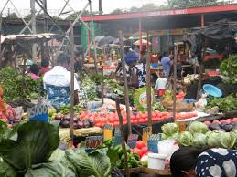

The market is located in Dambwa Central, one of the Livingstone’s suburbs. This is an open market where local people buy assorted foods and second-hand clothes. The food sold here includes fresh vegetables, fruits and dried produce, mainly supplied by local villages. The market is open from 06h30 to 18h30 every day.

### Historic Tour of Livingstone

Two hours are spent walking and driving around Livingstone, looking at the first school, hospital, library, sports club, churches, the High Court and the old North-Wester Hotel and learning of its famous history. The railway reached Victoria Falls in 1904 and the bridge was completed in 1905. It was then decided to move the town from the Old Drift at the river to the current site at Constitution Hill. In 1907 it became the capital of then-Northern Rhodesia and remained so until 1935 when Lusaka became the capital. While the town was well planned, it was also split; the railway workers lived at the bottom of the hill and the administrators and business people at the top of the hill and the two rarely mixed.

*Departure: 08h30 / 14h30*

*Minimum: 2 / Maximum: N/A*

*No age restriction*

### Livingstone Museum

The Livingstone Museum is one of a kind in this area. It contains the most comprehensive memorabilia of the explorer Dr David Livingstone, including authentic maps and diaries, and covers the history of the region from its formation right up to the present day. The Museum also contains Anthropological, Natural History and African Culture sections.

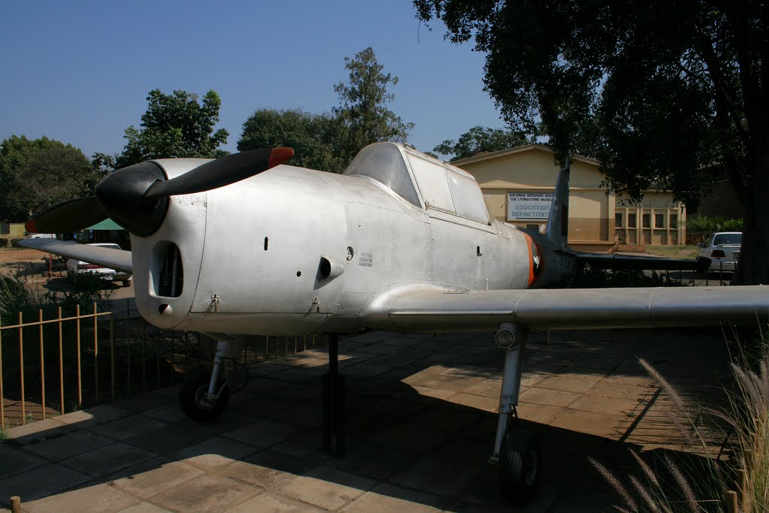

*Open daily except Christmas and New Year’s Day*

*Opening times: 09h00 – 16h30*

*Guided or self-guided tours are offered*

*Duration: 3 hours*

*No age restriction*

### Livingstone Island – Breakfast, Lunch or High Tea and Devil’s Swimming Pool

David Livingstone, the missionary explorer, first viewed the Falls (“Mosi-oa-Tunya”) from Livingstone Island, on the 16th of November 1855, with the help of the local tribesmen, using dugout canoes. He later named Mosi-oa-Tunya Victoria Falls after Queen Victoria. Livingstone Island is a unique picnic spot. Livingstone Island Tour and the Devil’s Swimming Pool is a combined activity offered by Tongabezi. This activity is only available from the Zambian side of Victoria Falls. Access to this unique Island is seasonal and depends entirely on the water level in the Zambezi River. Our expert guide will explain the flora and fauna, history and geology of the Victoria Falls.

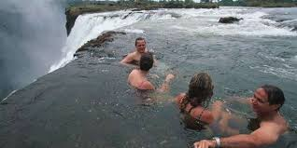

*Season: July – March (depending on water levels)*

*Duration: 1 hour for breakfast, 2 hours for lunch and 1 ½ hours for high tea.*

*Minimum age: 5 years*

### Chobe Day Trip – Full day

Clients will be transferred to the ferry and cross by boat to the Botswana border where they will be met by their guide. From here they proceed straight to the Chobe River where they will spend the morning viewing game. Tea, coffee and biscuits are provided. The morning cruise ends at around 12h30 and clients are then taken to the Chobe Safari Lodge on the riverbank for lunch. Afterwards, clients are taken on an afternoon game drive in Chobe National Park where they will have the opportunity to enjoy the Park’s abundant wildlife.

*Departure: Daily at 07h30*

*Duration: 6 hours*

*Minimum: 2 / Maximum: N/A*

*Minimum age: 4 years*

### Chobe Day Trip – Half day

Clients will be transferred to the Kazungula border where their Botswana guide will meet them. Their morning activity can be either a game drive in Chobe National Park, or a morning cruise on the river. Tea, coffee and biscuits are provided. Lunch at the Chobe Safari Lodge on the riverbank is optional.

*Departure: Daily at 07h30*

*Duration: 3 hours*

*Minimum: 2 / Maximum: N/A*

*Minimum age: 4 years*

### *African Queen* Cruises

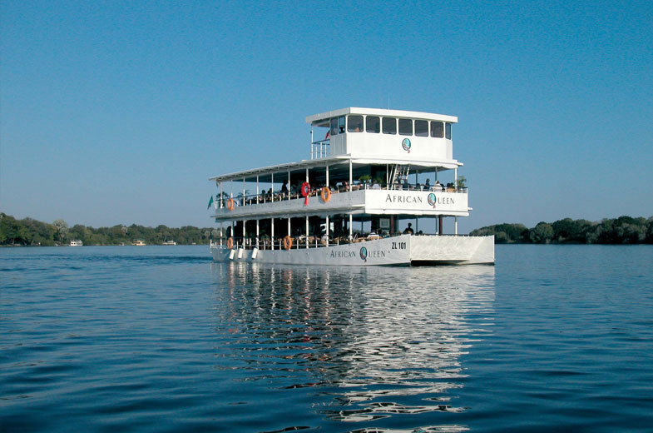These activities offer the spellbinding combination of the mighty Zambezi River and the gracious hospitality of the *African Queen*. A cruise on the *African Queen* or the *African Princess* is an unforgettable experience that will take you back in time to an era where time stood still. The Zambezi River cruise is a superb way to relax and enjoy the beauty of the River. Clients may have the opportunity to see a variety of game including hippo, crocodile, and elephant and sometimes even rhino, as well as enjoy the many different bird species. Options include:

### Breakfast Cruise – by pre-arrangement only

This cruise is perfect for the early riser and a wonderful opportunity for keen birders. Inclusive of a cooked breakfast, fruit, muffins, tea/coffee and orange juice, this is a beautiful time of day to be on the river as there are often fewer boats, which gives one a real sense of privacy.

*Minimum: 20 / Maximum: 120*

*Duration: 2 hours*

### Midmorning Cruise

On our midmorning cruise you will experience tranquillity at its best on the Zambezi River. Light snacks and pastries are served during the cruise.

*Departure: 09h30*

*Duration: 2 hours*

*Minimum: 10 / Maximum: 120*

### Lunch Cruise

Lunch includes a variety of salads, fresh bread rolls, stir-fried chicken, beef and vegetables, desserts, tea, coffee, beer, wine and soft drinks. All food is cooked on board on a “skottel braai” (gas cooker) so it is served fresh and hot.

*Departure: 12h30*

*Duration: 1 ½ hours*

### Sundowner Cruise

This is a popular cruise and includes finger snacks, beer, wine, sparkling wine and soft drinks. There are great photographic opportunities, often with spectacular African sunsets.

*Departure: (winter) 15h30, (summer) 16h00*

*Duration: 2 hours*

### Captain’s Cabin

For a personalised service fit for royalty, enjoy the view from our top deck in the company of the captain of the *African Queen* or the *African Princess* and your own service staff. In your exclusive transfer, you will be accompanied by your guide who will also serve you bottled wines, premium brand drinks and snacks within the comfort of the Captain’s Cabin.

The Captain’s Cabin has the capacity to hold the following number of guests.

• *African Queen*: A maximum of 10 guests

• *African Princess*: A maximum of 6 guests

***NOTE:*** Minimum number for both the vessels is 2 guests

### *Lady Livingstone* Cruises – Breakfast, Lunch or Sunset

The *Lady Livingstone* was built in 2008 to run in conjunction with the newly built David Livingstone Safari Lodge & Spa, and is moored on a private jetty off to one side of the hotel. It is a three-decker River Cruiser designed to seat 144 people. The lower deck accommodates 74 people, the middle deck up to 50 people and the top deck accommodates 20 people in private luxury. The cruise travels along the river boundary of Mosi-oa-Tunya National Park, where clients are likely to see hippo, crocodile, as well as plentiful birdlife. Possible other sightings include elephant, giraffe, and buffalo. An experienced guide accompanies each cruise and has strong knowledge on the wildlife and local history of the area.

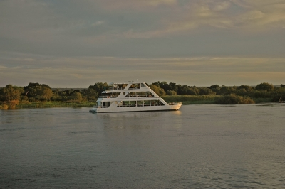

*Breakfast Cruise & Lunch Cruise – Available on request*

*Minimum: 10 passengers*

*Sunset Cruise:*

*September – April – departs 16h30 returns 18h30*

*May – August – departs – 16h00 returns 18h00*

*Sunset cruise includes freshly baked snacks and fully stocked bar included in the price of the cruise. There will also be a cash bar on board for drinks.*

### Jet Extreme

Jet Extreme is the first jet boat operation of its kind in Africa, powering through the mighty Zambezi River, buzzing past rocks and jet spinning all in the spectacular setting of the Batoka Gorge, one of Zambia’s natural treasures. Jet Extreme has recently installed a unique cable car system which enables clients to effortlessly enter and exit the mighty Batoka Gorge while taking in the awesome view.

### Jet Boat Ride

Transfer to and from the river through traditional African villages in a comfortable four-wheel drive vehicle, before embarking on a thrilling 30-minute jet boat ride. The boat is a Kwik Kraft Super Twin, with capacity for 22 passengers plus boat crew.

*Departure: Hotel pick up at 07h30 to return by approximately 10h30 (morning); 12h30 to return by approximately 15h30 (afternoon)*

*Duration: 3 hours*

### Canoeing

Experience the mighty Zambezi River by canoe. Launching upstream of the Victoria Falls, guests will travel along the banks of the Zambezi River seeing Zambezi National Park on the Zimbabwe side and Mosi-oa-Tunya National Park on the Zambian side.

*Minimum: 2 / Maximum: 24*

*Age restriction: 12 years*

Guests can choose between full-day, half-day and overnight options:

### Half-day Canoe Safari

Guests are picked up from their respective lodges in Livingstone at 07h30 to the canoe starting point upriver. The transfer takes approximately 40 minutes. Tea, coffee, bacon and egg rolls are served at check in at the waterfront. This is followed by a safety talk and paddling practice before setting off on the canoe safari. Please note that no lunch is served on the half-day safari, which is only available in the mornings, unless by specific request for larger groups. Guests are transferred back to their hotel/lodges at approximately 12h30.

### Full-day Canoe Safari

This follows the same schedule as the half-day safari, however it also includes lunch, which is served on an island in the middle of the Zambezi and consists of cold meats and salads. Guests are transferred back to their hotel/lodge at approximately 16h00.

### Overnight Canoe Safari

Again, this safari follows the same schedule as the full-day safari, however at approximately 16h30, clients reach the overnight point, an island opposite Thorntree Lodge. The campsite is set up before clients arrive and all bedding is provided. There is a toilet and shower on the island. Clients will be served dinner and drinks on the island before retiring to bed. After breakfast the following day, guests are transferred back to their hotel/lodge at approximately 08h30.

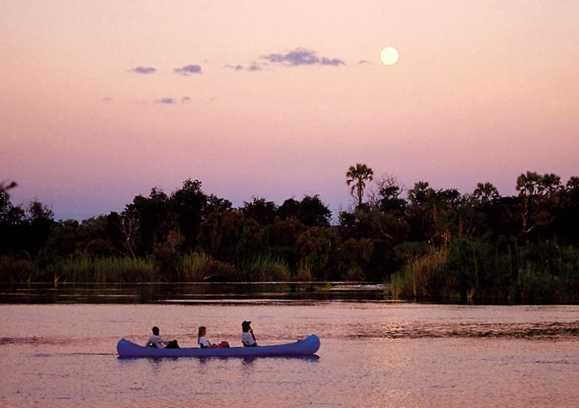

### White Water Rafting – Half, Full day

Commercial rafting first commenced on the Zambezi River in 1981 and since then this activity has grown in popularity to the point where a rafting trip on the Zambezi is now a regular feature in many tourist itineraries, and is now internationally acclaimed as the best one-day white water rafting trip available in the world. Clients should be reasonably fit for this activity, as there is a fairly steep walk into and out of the Batoka Gorge as well as the white water rafting activity itself. Tea, coffee and biscuits are served in the morning at check in, after which clients are taken to the Gorge for their safety briefing before the day’s activity commences. Depending on the activity booked, a light lunch is either served in the gorge between rapids (full day), or at the top of the gorge (half day). Clients booked for a full day will continue on rafting in the afternoon and can expect to be returned to their hotels at 15h30 (high water) and 17h00 (low water).

***Please note*** that rafting can close between January and June for safety reasons, due to water levels being too high.

*Departure: Between 08h00 and 08h15 (half-day morning and full day); between 10h00 and 10h15 (half-day afternoon)*

*Minimum: 4 / large groups on request*

*Minimum age: 15 years*

### Rafting & River Boarding Combination – Half, Full day

Take on the meanest Zambezi rapids with flippers and a boogie board. This experience combines the best of rafting with the challenge of spectacular river boarding and runs during low water and, for a limited period only, during high water. River boarding is available all year round but is dependent on water conditions.

*Minimum: 2 (if rafting trip is already running) / Maximum: 12*

**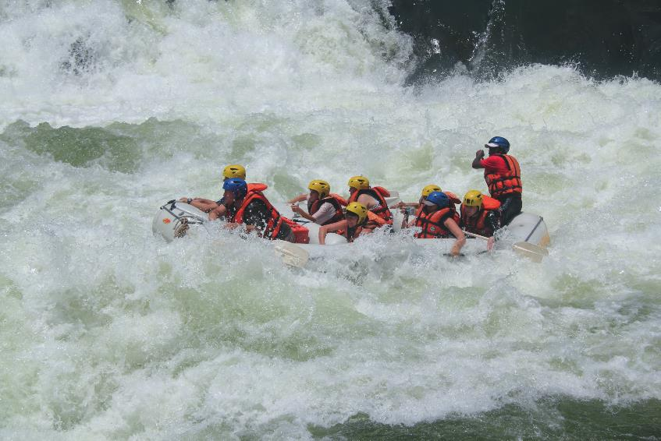***Minimum age: 15 years*

### River Safaris – Breakfast, Lunch or Sunset

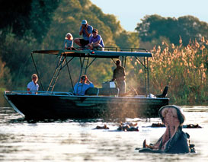This is a personalised and environmentally-friendly upper-river safari experience. The specifically designed propeller-free safari boats are able to cross the numerous rapids along the upper Zambezi River comfortably. An experienced skipper will conduct your safari, and explain the river, the wildlife, the people and the history of the area.

*Departure: Morning Cruise 08h00, Lunch Cruise 11h30, Sunset Cruise 15h30 or 16h00 depending on the season*

*Minimum: 2*

### Horseback Safaris

We offer clients exhilarating horseback rides from the Falls Resort. All riders, novice to experienced, will enjoy the leisurely trails, led by experienced guides within the confines of a National Park. Trails take place through pristine African bushveld with exceptional views of the Victoria Falls and Zambezi River. Large mammals are often seen during the dry season and birdlife is prolific. Refreshments are served en route. Guests can choose between a two-hour-long ride, or a half-day ride with lunch served at the stables.

*Departure times: 07h00, 10h30, 14h30 and 16h00.*

*Longer trails are available on request*

*Minimum age: Children under the age of 16 will require written permission from a parent or guardian*

*Minimum: 1 or 2 / Maximum: 12*

*Minimum numbers required for the 2-hour trail is 1 person*

*Minimum numbers required for the half-day trail is 2 people*

### https://encrypted-tbn2.gstatic.com/images?q=tbn:ANd9GcSw_G085aiZokZSMgBcVl9il2kgbErk6x6LjlCJNMGUwVRPMh_GGame Drives/Walks in Mosi-oa-Tunya National Park

The Mosi-oa-Tunya National Park is home to white rhino, elephant, buffalo, giraffe, zebra and various other species. Although small by African standards (1 600 hectares), this increases the chance of seeing game. Clients are also shown some historic sites such as the Old Drift where the original white settlers lived before 1904. Although we do not operate this activity ourselves, we are happy to assist with reservations on your behalf.

### Elephant-Back Safari

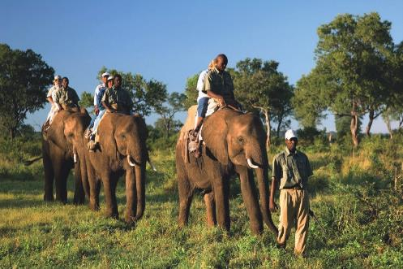We offer a once-in-a-lifetime insight into these gentle giants. Together with this ecologically-friendly method of game viewing, a strong emphasis is placed on an elephant experience rather than just an elephant ride and guests are encouraged to interact with these majestic and intelligent African mammals. There are several options to choose from:

### Morning Ride

Pick up from Waterfront at 06h10

Pick up from Bush front at 06h15

Pick up from Sun / Royal at 06h30

Pick up from town accommodation at 06h45

Drop off at accommodation between 10h30 and 10h45

Tea, coffee and scones will be served at the end of the trip

Clients are required to pay park fees for this activity

Minimum: 2 / Maximum: 12

Minimum age: 10 years, and a guardian must accompany children under the age of 16 throughout the trip

### Mid-Morning Ride

Pick up from Waterfront at 10h10

Pick up from Bush front at 10h15

Pick up from Sun / Royal at 10h30

Pick up from town accommodation at 10h45

Drop off at accommodation between 14h30 and 14h45

Snacks and drinks will be served at the end of the trip (including local wines, beer and spirits). Clients are required to pay park fees for this activity

Minimum: 2 / Maximum: 12

Minimum age: 10 years, and a guardian must accompany children under the age of 16 throughout the trip

### Afternoon Ride

Pick up from Waterfront at 14h10

Pick up from Bush front at 14h15

Pick up from Sun / Royal at 14h30

Pick up from town accommodation at 14h45

Drop off at accommodation between 18h15 and 18h30

Snacks and drinks will be served at the end of the trip (including local wines, beer and spirits). Clients are required to pay park fees for this activity

Minimum: 2 / Maximum: 12

Minimum age: 10 years, a guardian must accompany children under the age of 16 throughout the trip.

### Elephant Interaction

The head guide will give a short introductory talk including safely aspects, after which guests will be introduced to the elephants and the rest of the guides. Guests will interact with the elephants for about 20 minutes.

Pick up from Livingstone accommodation is between 10h30 and 10h45

Drop off at Livingstone accommodation is between 11h45 and 12h00

Bottled water will be served at the end of the trip

Minimum: 4 / Maximum: 12 (larger groups can be catered for on request)

Please note that elephant interaction does not include transfer costs

Minimum age is 10 years and a guardian must accompany children under the age of 16 throughout the trip

### High Wire Adrenalin Activities

A collection of mind-blowing extreme adrenalin activities set on the edge of the Batoka Gorge, 300 metres from the Victoria Falls. There is something for every age and level of courage:

**Full Day** –Consisting of Abseiling, Rap Jumping (Forward Abseiling), Flying Fox (High Wire) and the Gorge Swing; including breakfast, lunch, cold drinks, beer and transfers.

**Half Day** – Consisting of an Abseil or Rap Jumping, 2 Flying Fox and 2 Gorge Swings with drinks and transfers but excluding lunch. Guests have a choice of doing a morning or an afternoon session.

**The Gorge Swing** – Consisting of a single Swing. Limited drinks are provided as well as transfers.

**Tandem Swing**–Consisting of a single Swing, including limited drinks and transfers.

**Flying Fox** *–* Consisting of 2 Slides on the High Wire in each of the sitting and the flying positions. Transfers and limited drinks offered.

**Abseil Only** – Consisting of abseiling or rap jumping (forward abseiling). Transfers and limited drinks offered.

Minimum age: 8 years

### Helicopter Rides

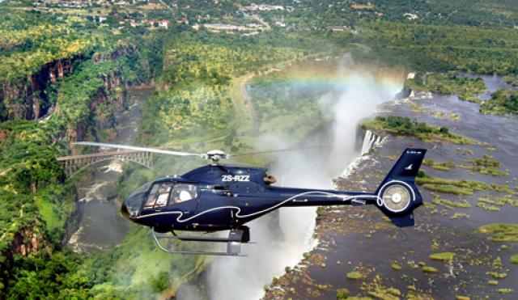

These 15-minute and 25-minute flights depart regularly throughout the day and offer spectacular photographic opportunities. For the 15-minute flight, we take off from Baobab Ridge helipad then climb to a height of 450 metres (1500 ft) on the way to the Falls. We will do one and a half orbits right to enable the passengers on the right side of the helicopter to video/photograph and view the mighty Victoria Falls then over the centre of the Falls. The pilot then executes one and a half left orbits to allow the passengers on the left the same views. The pilot will then fly directly over the Falls and fly straight to Long Island where we may see elephant and hippo, dependent on the time of year. The final leg is passing over the Mosi-oa-Tunya National Park where we may see buffalo and other game. The helicopter then heads back to Baobab Ridge.

For the 25-minute flight, we take off from Baobab Ridge helipad and fly low level to the Zambezi Gorge entering at Rapid 21. The flight will continue on to the steep Batoka Gorge, above the raging river to Rapid 26. At Rapid 26, the pilot will fly out of the gorge, back to the Victoria Falls where the flight will commence the same route as the short flight.

Notes: If there are 4 people travelling together they can be flown at one time. However, groups of 3 or less may be combined to fly with other guests. Any confirmed booking cancelled with less than 24 hours’ notice prior to flight time or any no shows will be subject to a 100% cancellation fee. This also applies to bookings made less than 24 hours prior to flight time.

Squirrel Helicopter which can accommodate 5 passengers

EC-120 Helicopter which can accommodate 4 passengers

EC-130 Helicopter which can accommodate 6 passengers

### Helicopter Gorge Lift Out

After rafting, the jet boat ride or the Gondola, the best way to return to Livingstone is by helicopter. Climbing out of the gorge and the road transfer takes up to two hours. The helicopter trip includes an exhilarating flight through the Batoka Gorge, circling over the Victoria Falls and landing at Maramba Aerodrome.

### Helicopter Gorge Picnic

Guests will be flown by helicopter to Rapid 21 (Bobo Camp) where they will enjoy a picnic at a beautiful spot with stunning views of the river and the gorges. Afterwards, guests will also be flown out by helicopter.

Minimum: 6 / Maximum: 24

### Microlight Flight

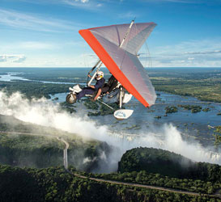Take the flight of your life on a microlight operated by Batoka Sky Adventures. There are two flight options:

**Short flight (15 minutes):** Take off and fly over the Zambezi River and onwards to the Victoria Falls. Participants will then circle over the Falls and the islands before returning to Maramba Aerodrome.

**Long flight (30 minutes):** Take off and fly over the Zambezi River and onwards to the Victoria Falls. Participants will then circle over the Falls and the islands, before flying upstream along the Zambezi River to Kalai Island. They will then low-level over the Mosi-oa-Tunya National Park for unique game viewing before returning to Maramba Aerodrome.

*Weight restriction: 100 kg. For customers over the weight limit please inform us before booking. No cameras allowed on flights.*

*Departures: 07h00 – 10h00 / 15h00 – 18h00*

*Professional photographers:*

Accredited professional photographers, who want to use the microlight as a platform to film from, will need to:

• Apply in writing at least 14 days in advance.

• On application provide full traceable professional qualification and exact detail of request.

• Once the request is confirmed, the charter rate will apply with a minimum of a one-hour charge.

• Safety precautions may mean that the pilot (whose decision is final) may not allow the photographer with his/her camera on board. A full refund will be paid if no flight takes place.

### Livingstone Adventure Packages

**Option 1**: 4 hours, African Queen Cruise, Helicopter/Microlight, Short Flight and a Tour of the Falls.

**Option 2**: 4 ½ hours, River Safaris Cruise, Helicopter/Microlight Short Flight and a Tour of the Falls.

**Option 3**: 6 hours, Half Day Canoe Trip, Helicopter/Microlight Short Flight, Tour of the Falls or Crocodile Farm.

**Option 4**: 4 ½ hours, Jet Extreme, Helicopter Flight, *African Queen* Cruise

**Option 5**: 6 ½ hours, *African Queen* Cruise and Dinner, Helicopter/Microlight Short Flight and a Tour of the Falls.

**Option 6**: Your package, choose any of the activities from Options 1-5 for your own Adventure Package.

### Royal Livingstone Express

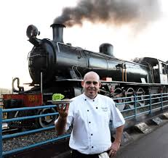The Royal Livingstone Express offers discerning guests the ultimate fine-dining experience, going back in time to the age of steam train travel, using the historic Mulobezi Railway line, formerly one of the largest private railway networks in the world. The Royal Livingstone consists of five carriages and is fully air conditioned.

The train travels to entrance of Mosi-oa-Tunya National Park, and departs from the Park’s Western Gate, crossing the Sinde River bridge where the locomotive will ‘run around’ using the “Sinde Siding”. After sunset, a dinner bell will sound and the train manager will announce dinner and lead guests through to the dining carriages where a five-course meal awaits.

Days of operation: Thursday, Friday and Saturday

Schedule: (summer: September to March) Depart 18h00 and return by approximately 21h00; (winter: April to August) Depart 17h30 and return by approximately 21h15

Minimum: 12 / Maximum: 160 passengers if only drinks and snacks are required and 92 passengers if seated for dinner

No age restriction

### Steam Train

Our aim is to promote the historical and romantic aspects of this fascinating era. And what better way to capture a legendary era than on a fully refurbished train, viewing mystical Africa the way it would have been done over one hundred years ago, in the comfort of an authentic first-class steam train. This beautifully restored steam train has a 1954 class 14a steam locomotive, dining cars and first-class coaches. It can carry up to 220 passengers, who will be attended to by our enthusiastic and well-trained staff. This African steam safari will appeal to those who want to see this part of the world for its beauty and history.

### The Bridge Run

Sundowners on the Victoria Falls Bridge – 1 ½ hours. You sit in the luxury and comfort of our lounging car or wander along on this beautiful bridge, whilst viewing the majestic Victoria Falls with its breathtaking, picturesque gorge and the turbulent Zambezi River 110 metres below. A selection of light snacks, (local beers, wine, G&Ts, minerals, cordials), will be served by our ever-attentive waiters.

### The Zimbabwe and Zambia Steam Shuttle

This is a service for groups wishing to travel between Victoria Falls and Livingstone. Shuttle will operate either direction, with timings to be arranged with clients.

Moonlight Dinner Run (Zimbabwe side only)

For an idyllic, romantic interlude we have an evening run. First, the train will head for sunset cocktails on the majestic Victoria Falls Bridge, where you will sit in comfort and safety beneath the spray of the magnificent Victoria Falls. After sunset, a slow, luxurious steam journey south takes you into the Zambezi National Park for a romantic dinner. Huge bonfires greet you on arrival and keep you warm in winter or relax in the cool breeze of a summer’s eve, wining and dining to the night calls of wild Africa.

****

### Description: http://farm3.static.flickr.com/2170/1613128605_ce7371d28d_b.jpgHarare City Tour

Visit downtown Harare. Historical buildings like Parliament, the High Court, various churches and old shops. Also visit:

* Harare Kopje, the highest point of Harare with 360-degree views of the city
* Mbare Musika with its huge vegetable market and the big hall with curios
* Doone Estate with Chapungu Sculptures and various shops for souvenirs

Duration: 2 1/2 – 3 hours

### Tour of Lake Chivero

Lake Chivero is a small National Park with a variety of small game and rhino. The National Park is home to a dam that supplies water to Harare city. You will also visit:

* The dam wall which offers a nice view of the Lake
* Kuimba Shiri which is a bird garden, on the shores of the Lake
* The Lion and Cheetah Park, a small zoo with a separate mini-park for lions

Duration: 4 – 5 hours

### Historical Tour: Queen Victoria Museum – National Archives

Queen Victoria Museum is a small museum that concentrates on natural history and ethnology. You will visit the National Archives which house the priceless collection of Rhodesian Africana in the form of diaries, notebooks and reports of various origins. Some of the original works of the greatest names in African exploration and missionary work can be viewed.

Duration: 2 – 3 hours

### Harare by Night

A visit to one of the many small and cosy entertainment centres for live music: Book Café, Mannenberg, Bedazzled and others. Have fun in a pleasant and safe environment.

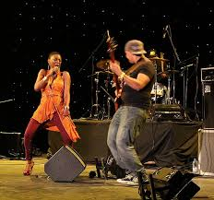

*Duration: 3 – 5 hours*

### Harare Township Excursion

Visit a township with a local guide. You will see small businesses at work in the street, arts and craft, small markets, and above all meet the friendly and always smiling people of Harare, the city that never sleeps.

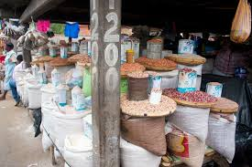

*Duration: 2 – 3 hours*

### Domboshava Rock and Cave Paintings

Domboshava derives its name from the words *dombo* (large stone or rock) and *shawa* (red). This hill is a massive granite dome containing several shelters with notable rock paintings. These include fine animal and human depictions of several different styles. Some of the human figures are believed to be San representations of Bantu-speaking people.

Duration: 3 – 4 hours

### Goma Kurira

Ngoma Kurira (“the drums are sounding”) is one of the dominant hills of the Domboshawa area, about 30km north of Harare. It is a granite hilly area lying amongst the headwaters of the Mazoe River. The climb to this beautiful area with its well-preserved rock paintings is quite challenging.

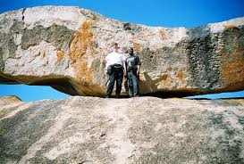

*Duration: 4 – 5 hours*

### Harare Arts Tour: National Gallery and Gallery Delta

*National Gallery*

Examples of the Shona sculptures are on permanent display, along with national, regional and European art.

*Gallery Delta*

Housed in one of the oldest houses of Harare, this gallery has a stunning collection of mainly modern paintings created by local artists.

Duration: 3 – 4 hours

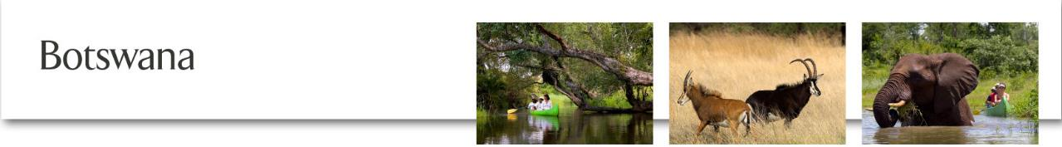

Please note that clients will need a passport and where necessary a visa to enter Botswana. The client’s visa must be purchased in advance from a Botswana High Commission and visa fees are not included in our transfer rates. Under no circumstance can a visa be purchased or obtained at the border.

## Botswana Transfers – minimum 2 people

Our transfers to and from Botswana are operated at pre-scheduled times and the journey from Victoria Falls to Kasane is approximately 1½ hours excluding Immigration formalities at the border. We drop clients off at the Zimbabwe border for our Botswana counterpart to pick up and transfer guests to their intended destination.

|  |  |
| --- | --- |
| **Scheduled Departure Times**  **To and from Botswana** | |
| **Victoria Falls – Kazungula Border** | **Kazungula Border – Victoria Falls** |
| 07h30 | 08h30 |
| 09h30 | 10h30 |
| 11h30 | 12h30 |

*Transfers also run to coincide with scheduled flights to/from Victoria Falls Airport.*

### Chobe Game Drive

Venture into the legendary Chobe National Park to view the greatest elephant population density in Africa. Our famous Chobe game drive is designed to soak up the most of this unique experience, so we handpick our licensed professional guides, and we have adapted our 4x4 open safari vehicles to provide superb photographic vantage points and easy visibility.

*Departs: Daily, on request*

*Morning: Summer 06h00 – 09h00 (Sep – May), winter 06h30 – 09h30 (Jun – Aug)*

*Afternoon: Summer 15h30 – 18h30 (Sep – May), winter 15h00 – 18h00 (Jun – Aug)*

*Duration: 3 hours*

*Minimum age: 4 years*

### Chobe Boat Cruise

Cruise the breathtaking Chobe River and marvel at the variety and numbers of game and spectacular sunsets. Encounter hippo and crocodile along the way, as well as other wildlife that converge on the water to drink. Open-sided boats provide superb photographic opportunities, and our licensed professional guides know just where to guide you for the best experience on the River.

*Departs: Daily on request at 09h30 and 15h30 (winter 15h00)   
Duration: 3 hours*

*Minimum age: 4 years*

### Victoria Falls Day Trip

Nothing prepares you for the awe-inspiring sound and spray drama of majestic Victoria Falls, as millions of litres tumble over the Falls into the gorges below. Hearing tales about *Mosi-oa-Tunya*, ‘the smoke that thunders’, and seeing it for yourself, are two entirely different things. Our specialised day trip includes a full morning tour of the Falls, and we’ll amble through the misty rain forest (a fun experience, we promise), and soak up the beauty. We’ve selected the perfect vantage points from which to view the Main Falls, namely Horseshoe Falls, Rainbow Falls, The Boiling Pot, Cataract Island and Livingstone Island. You’ll have built up a fine appetite for a leisurely lunch (not included), before we visit a classic Open African Craft Market where you’re welcome to fine tune your bartering skills! We’ve built in time thereafter to explore the little town of Victoria Falls. It’s a full day of the mighty Victoria Falls, for the power of this wonder of the world will capture your full attention!

*Departs: Daily on request at 08h00 from Chobe and departing Victoria Falls at 15h00  
Duration: Full day  
Note: Passport required and visa conditions may apply.*

# Booking Terms & Conditions

Our offices are open 7 days a week throughout the year from 08:00 to 17:00. Please note the following booking terms and conditions:

* All bookings **must be made in writing** via email.
* Any booking changes **must be made in writing** before our reservationists will confirm them.
* Cancellations **must be made in writing** at least 24 hours in advance or full payment will still be required.
* “No shows” will be charged in full.
* The right is reserved to amend/cancel bookings subject to weather conditions or any unforeseen event.
* Where stated, minimum persons do apply.
* Group Tour Leaders may receive discounted or free travel at our discretion.

## Payment Details

### Generally:

Payment must be made in full prior to date of travel.

### Approved account holders:

Payment must be made within 30 days of receipt of statement. Any payment outstanding after 30 days will result in temporary closure of your account. Payments outstanding after 90 days will lead us to close your account permanently.

## Contact Information

### Zimbabwe

P.O. Box 288, Victoria Falls, Zimbabwe

Tel: +263(13) 43371 -3 or 41020

Office Cell: +263 (712) 456 557 (after hours)

Fax: +263 (13) 45942

Email: [tours@wilderness.co.zw](mailto:tours@wilderness.co.zw)

### Zambia

P.O. Box 60434, Livingstone, Zambia

Tel: +260 213 321578/79/80

Fax: +260 213 321581

Office Cell: +260 (977) 882 431

Manger Cell: +260 (977) 882 431