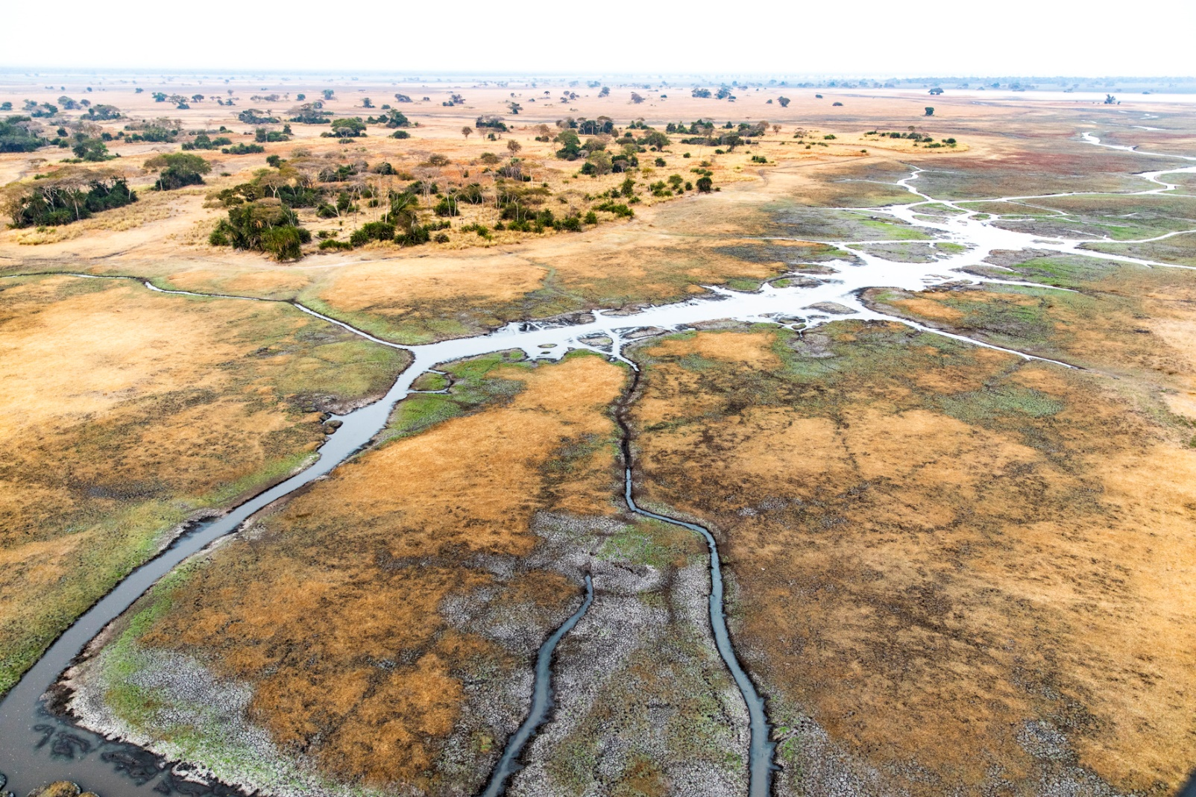

**Wilderness Safaris announces daily flights to BUSANGA plains for 2020 SEASON**

**December 2019 – Wilderness Safaris is set to improve access to Zambia’s extraordinary Busanga Plains by introducing daily flights between Kafue National Park and Lusaka or Livingstone during August, September and October 2020. In partnership with Wilderness Air Zambia, which is operated by Staravia, the initiative will increase travel convenience into the region while cutting down on complexities.**

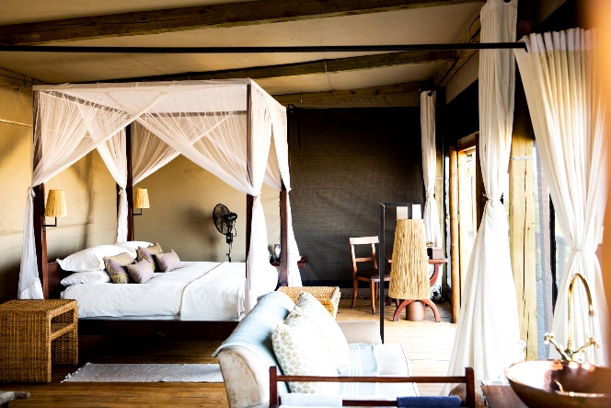 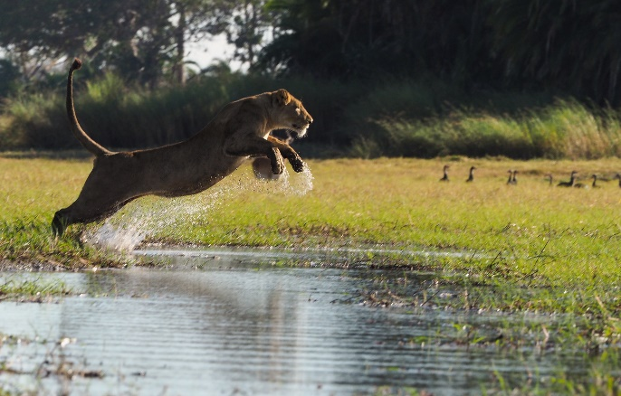 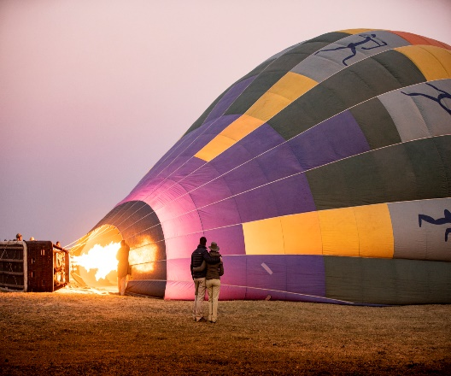

“Many of our guests don’t know how straightforward it is to connect to various southern African countries, which is why we’re thrilled to offer these daily flights to Busanga, offering even more ways to easily access one of the most remote and pristine wilderness areas in Zambia. It showcases just how simple and efficient flying into the region is, and encourages our guests to do more travelling to Busanga – and in so doing, make a genuine difference to local communities and conservation”, says Alison May, Wilderness Safaris Retail Sales Manager for North America.

There are a number of convenient route options that offer travellers easy access to Busanga Plains – such as, but not limited to, flying from Cape Town, South Africa to Kafue through Livingstone, or flying from Botswana to Kafue, also through Livingstone. In addition, guests can travel from Zimbabwe to Kafue, either from Mana Pools via Chirundu, or from Hwange National Park. This will be made even easier with the availability of Wilderness Air Zambia’s daily flights offering.

Wilderness Safaris’ pioneering ecotourism presence in the Kafue continues to play a crucial role in the preservation and monitoring of unspoiled wilderness and wildlife, contributing to the conservation of the Park’s 2.4 million hectares as well as 19 Vulnerable and Endangered species. Kafue’s rich biodiversity is incredible, with some 55 large mammals, including 20 ungulate and six cat species, as well as nearly 500 bird species.

Despite the challenges Wilderness Safaris has faced since opening its camps in the Busanga Plains in 2006, the company has made great strides in the region’s ongoing biodiversity conservation, leading to a direct positive impact on local economies. By travelling with Wilderness Safaris, each guest becomes a conservationist in their own right, helping the company to contribute more than USD500 000 in concession fees to Kafue National Park each year.

**Ends**

**Notes to Editor**

**About Wilderness Air:**

* Wilderness Air is proud to be the air partner of Wilderness Safaris, Africa’s leading authentic and sustainable ecotourism company with private access to some of the finest wilderness and wildlife areas in Africa.
* Wilderness Air operates a varied fleet of light aircraft, chosen for their ability to transport visitors comfortably and safely to remote wilderness destination with dirt airstrips.
* The company began operating in 1991 with one aircraft based in Botswana servicing two camps in the Okavango Delta. Today, Wilderness Air is also based in Namibia, Zambia, which is operated by Staravia, and Zimbabwe and operates over 35 aircrafts, with over 50 pilots.
* Wilderness Air is privileged to fly into some of the most pristine wilderness destinations in the world. It believes flying is an integral part of guests’ travel experience and that its pilots’ passion and professionalism can make a genuine contribution to journeys that changes lives.
* For more information, visit **www.wilderness-air.com**

**About Wilderness Safaris:**

* Since 1983, Wilderness Safaris has been dedicated to conserving and restoring Africa’s wilderness and wildlife by creating life-changing journeys and inspiring positive action.
* As Africa’s leading authentic and sustainable ecotourism operator, Wilderness Safaris operates camps and safaris in some of Africa’s best wildlife and wilderness areas across seven countries: Botswana, Kenya, Namibia, Rwanda, South Africa, Zambia and Zimbabwe. In this way it offers its guests private access to almost 2.5 million hectares (over six million acres) of Africa’s most remote and pristine wildlife areas, while remaining fiercely committed to protecting our planet’s precious natural and cultural resources.
* Wilderness Safaris is deeply committed to its 4Cs sustainability ethos of Commerce, Community, Culture and Conservation. It firmly believes that its single most important achievement to date is to have built a sustainable business model that does not compromise environmental principles and that provides jobs, training, skills, careers, adjusted horizons, hope and a realistic alternative to less sustainable development.
* Recognising that conservation is as much about people as about the environment, the company has pursued important goals through its two non-profit partners, [**Children in the Wilderness**](http://www.childreninthewilderness.com/) and the [**Wilderness Wildlife Trust**](http://www.wildernesstrust.com/), both of which have helped change the face of nature-based tourism in Africa.
* Wilderness Safaris is part of [**Wilderness Holdings**](http://www.wilderness-holdings.com/), a group of ecotourism companies that together use responsible tourism to build sustainable conservation economies in Africa.
* For more information, visit[**www.wilderness-safaris.com**](http:// www.wilderness-safaris.com/)

**[](https://www.facebook.com/Wilderness-Air-Africa-205688529442877/) [](https://twitter.com/wearewilderness) [](https://www.youtube.com/user/WildernessSafaris) [](https://www.instagram.com/wearewilderness/)**

**Issued by:** *Wilderness Air* | T: + 27 11 257 5000 | [www.wilderness-air.com](http://www.wilderness-air.com) | [media](http://info@childreninthewilderness.com)@wilderness-safaris.com